Lesson Plan Title: Clay Slab Gnomes Length: 8 days

Note: Before you plan and write art experiences; pre-assess your students based on the proposed concepts, enduring understandings, and objectives of the unit/lesson(s). You may also gather this information from (previous) teachers, by reviewing already completed artwork, consulting curriculum materials, etc., to get a better understanding of what content students already know and what they will need to know to be successful.

Pre-Assessment:
This will need to be done prior to teaching your lesson. Outline the method you will use to determine the skill/knowledge level of your students based on the concepts/enduring understandings/objectives of the lesson. (Hint: turn these into questions.) Be specific in describing what you would recognize as proficient skill/knowledge.
How do you make a character?
What features do they have?
What is their personality like?
How can you translate this into your artwork?
How does this change the way you look at a work of art? Do you notice elements that you did not see before?
Does it change the meaning and your opinion?
How can you turn a character you write about into a work of art, the portrays emotion and personality?

Performance:
What will students accomplish as a result of this lesson? This can be presented to students in the form of a story. In this narrative the students take on a role and create a learning product about a specific topic for a certain audience. (RAFT – Role / Audience / Format / Topic)
Role: Artist
Audience: Classmate
Format: Clay Slabs
Topic: gnomes

You the artist are writing a short story about a gnome character you create out of clay slab. You will use the clay slabs as the body and then use other techniques you have learned so far to bring your character to life. The gnome should be based off the one in your story and you will have to translate not only the looks but the emotion and the personality of your character into a 3D clay sculpture.

Concepts:
List the big ideas students will be introduced to in the lesson. These ideas are universal, timeless and transferrable. Examples of concepts used in art might include: Composition, Patterns, Technique, Rhythm, Paradox, Influence, Style, Force, Culture, Space/Time/Energy, Line, Law/Rules, Value, Expressions, Emotions, Tradition, Symbol, Movement, Shape, Improvisation, and Observation Look for concepts in the standards, content specific curriculum, etc.
Collaboration, style, composition, techniques, shape, observation, process, product, time, influence, emotions, symbols, referencing, connecting

Enduring Understanding (s):
Enduring Understandings show a relationship between two or more concepts; connected with an active verb. The best enduring understandings not only link two or more concepts; but demonstrate why this relationship is important. Like concepts, they are timeless, transferrable and universal.
Artists can make connections to different content areas and practices through artmaking
Artists practice
Artist use various methods of planning and practice refining to create works of art

Standards: (All lessons should address all standards.)
1. Observe and Learn to Comprehend
2. Envision and Critique to Reflect
3. Invent and Discover to Create
4. Relate and Connect to Transfer

Objectives/Outcomes/Learning Targets:
Objectives describe a learning experience with a condition → behavior (measurable) → criterion. Aligned to: Bloom’s – Standards – GLEs - Art learning and, when appropriate, Numeracy, Literacy and Technology. Should be written as: Objective. (Bloom’s: _____ - Standard: _____ - GLE: _____ -Art learning: _____ -Numeracy, Literacy, and/or Technology)
1. Provided information and planning, SWBAT write a 1 page short story about a gnome, fill out a characteristics chart based on their story and create three sketches of what their gnome will look like.
Bloom’s: understand, Standard: Comprehend, GLE 1: The characteristics and expressive features of art and design are used in analyzing and synthesizing the meaning in works of art, Art Learning: ideation. Literacy:writing a short organized story, practicing writing narratives,, vocabulary, practicing talking and writing about art and works of art, reading directions and brainstorming sheets, Numeracy: planning number of paragraphs, thinking about size and shape, number of elements needed to complete a story and have all of the information.
PGC’s:
- Analyze, interpret, and make meaning of art and design critically using oral and written discourse
- Explain, demonstrate, and interpret a range of purposes of art and design, recognizing that the making and study of art and design can be approached from a variety of viewpoints, intelligences, and perspectives

2. Given instruction, SWBAT construct a gnome using clay slab that is at least 8 inches tall and use good application of underglazes.
Bloom’s: apply, Standard: Create, GLE 2: Restructure and apply the technical skills and processes required to achieve desired results in producing works of art, Art Learning: tools and techniques, Literacy: vocabulary, listening to process, taking notes, asking questions, using story as a reference for their characters size and shapes, answering and asking questions., Numeracy: measuring our slab sizes and shapes to match up to height requirements and each other. Technology: access to google classroom with videos powerpoints and worksheets. Access to personal laptops for additional resources.
PGC’s:
- Develop and build appropriate mastery in art-making skills using traditional and new technologies and an understanding of the characteristics and expressive features of art and design
- Create works of art that articulate more sophisticated ideas, feelings, emotions, and points of view about art and design through an expanded use of media and technologies

3. Using prior knowledge SWBAT use at least six characteristics from their character chart, use past techniques, elements and principles of design and reference their stories to create a gnome out of clay that demonstrates good overall craftsmanship and understanding of processes and techniques.
Bloom’s: Create, Standard: Create, GLE 1: Achieve the ability to plan, anticipate outcomes, and demonstrate craftsmanship in creating a work of art, Art Learning: expressive features and inherent characteristics, Literacy: create a character chart by writing, reading their stories, familiarize themselves with vocabulary and definitions, discussing ideas with classmates and teachers, reading instructions and other resources, Numeracy: using a specific number of characteristics, studying shape and pattern, using size and proportion for characteristics.
PGC’s:
- Create works of art that articulate more sophisticated ideas, feelings, emotions, and points of view about art and design through an expanded use of media and technologies
- Recognize, interpret, and validate that the creative process builds on the development of ideas through a process of inquiry, discovery, and research

4. After showing examples of artists, discussing how stories or writing translate into art, SWBAT write a one page short story about a personal character in the form of a gnome and develop an understanding of the importance of artists statements when creating artwork.
Bloom’s: analyze, Standard: Transfer, GLE 1: Critical thinking in the arts transfers to multiple uses in life, Art Learning: Art history and culture, Literacy: reading, writing, making connections through art and writing, writing narratives with specific details for artwork, discussion with other classmates and teacher, using resources and planning guides, answering and asking questions., Numeracy: using a specific number of instructions, questions and pages, problem solving
PGC’s:
- Explain, compare and justify that the visual arts are connected to other disciplines, the other art forms, social activities, mass media, and careers in art and non-art related arenas

5.Using completed gnomes and stories, SWBAT to express individual intent and introspect their experience, process, product, failures, problems, successes and frustrations and real world connections/applications to how stories can help plan, transfer and change works of .
Bloom’s: evaluate, Standard: reflect, GLE 2:Concepts, issues, and themes in the visual arts can be used to communicate ideas in various other disciplines, Art Learning: Critical Reflection, Literacy: discussing artwork and writing , reflecting, using vocabulary, writing self reflections and reading to self grade, reading others artwork and stories and reflecting, reading artwork, making connections and discussing them, asking questions., Numeracy: studying and talking about size and proportions, numbers and measurements were used to make shapes that fit together, calculations and formulas used to make shapes and proportions, scaling and refining.
PGC’s:
- Recognize, articulate, and implement critical thinking in the visual arts by synthesizing, evaluating, and analyzing visual information
- Use specific criteria to discuss and evaluate works of art

Differentiation:
Explain specifically how you have addressed the needs of exceptional students at both end of the skill and cognitive scale. Describe the strategies you will use for students who are already proficient and need growth beyond what you have planned for the rest of the class, as well as modifications for students with physical and/or cognitive challenges. Students must still meet the objectives.

 | Access (Resources and/or Process) | Expression (Products and/or
 | - google classroom  - Teachers and classmates  - Handouts  - PowerPoint  - Personal laptops  - Slab roller  - YouTube videos  - Teacher and students samples  - Templates and guides | Gnome using slab techniques and stylistic choices based on material and student story.
Extensions for depth and complexity: | Access (Resources and/or Process) | Expression (Products and/or Performance)
 | After discussing Alessandro Gallo’s works of art students will have a basic understanding of how stories are used to create works of art. Students will be given outlines and guides in order to complete their own stories about a character that they will recreate using clay slab. They will first start with writing their stories related to personality then move on to making the physical characteristics using a character building chart. Using their chart they will make three sketches implementing these characteristics.Sketches will then transfer into their final model made out of slab. Using slab, texture and other learned techniques so far students will create their character. After the project is fired students will glaze according to the colors and meanings they chose through planning. | Students will create a gnome using a story they wrote about a gnome. The gnome will be a clay slab sculpture that portrays the physical attributes of the gnome in their story. The story has no physical descriptions of the character so students have to make them in correlation with the personality of the gnome in the story. Students learn to use slab, underglaze and previously learned techniques to create a clay sculpture. They also become familiar with using texture, color shape, writing, math, meeting size requirements, planning and transferring. The story will also be part of their artist statement so they can practice and understand how writing about artwork is just as important as creating it. It can change the work of art for the viewer and is the framework for creating for the artist.

Literacy:
List terms (vocabulary) specific to the topic that students will be introduced to in the lesson and describe how literacy is integrated into the lesson.
During the the powerpoint students will be discussing and reading information provided. They will be communicating and collaborating with classmates, asking questions and reading instructions. Students will also be using plans where they will learn new vocabulary terms and use writing outlines. Students will also be writing their own short stories that will be the bases for their artwork.

Materials:
Must be grade level appropriate. List everything you will need for this lesson, including art supplies and tools. (These are the materials students will use.) List all materials in a bulleted format.
computer
handouts
PowerPoint presentations
clay
rolling pins
canvases
guide sticks for rolling slab
slab roller
spray bottle
sponges
plastic bags
wood boards for clay to be stored on
kiln
underglaze
glaze
ruler
pencil
sketchbooks

Resources:

List all visual aids and reference material (books, slides, posters, etc. Be specific; include title, artist, etc. Make reference to where the material can be found. (These are the resources used by the teacher to support/develop the lesson.) List all resources in a bulleted format.
- Google classroom
- Teachers and classmates
- Handouts
- PowerPoint
- Personal laptops
- Slab roller
- YouTube videos
- Teacher and students samples
- Templates and guides

Websites used for artist information
https://www.artsy.net/artist/alessandro-gallo#!
https://coartmag.com/news/exhibition-report/alessandro-gallo-for-some-reason/
http://jonathanlevineprojects.com/unmaking-dont-want-grow-upby-alessandro-gallo/
https://cfileonline.org/exhibition-alessandro-contemporary-ceramic-art-cfile/

Preparation:
What do you need to prepare for this experience? List steps of preparation in a bulleted format.
- make the clay model
- fill out the worksheets
- create handouts
- make PowerPoint presentations
- make sure materials are set out and ready to go and students have access to them

Safety:

Be specific about the safety procedures that need to be addressed with students. List all safety issue in a bulleted format.
- Clay tools are to be used only on the clay
- do not throw clay tools or clay in the classroom or at any one else
- When cutting cut away from yourself or others around you.
- fingers should not be in slab roller only clay
- hair is up while using slab roller or rolling slabs
- do not eat or sniff underglazes
- underglazes should only be applied on clay surfaces
- no running or rough housing in the classroom

Action to motivate/Inquiry Questions:
Describe how you will begin the lesson to stimulate students interest. How will you pique their curiosity and make them interested and excited about the lesson? What inquiry questions will you pose? Be specific about what you will say and do to motivate students and get them thinking and ready to participate. Be aware of the varying range of learning styles/intelligences of your students. Some ideas might include: telling a story, posing a series of questions, role-playing, etc.
Show examples of Alessandro Gallo’s work. (A modern artist with animal/human hybrid sculptures that depict people in today's society) Students may be able to relate to this due to the art being modern, relatable, interesting and funny. We will talk about these characters stories by observing characteristics and students will get to give input and ask questions and begin to form stories about the artwork. From there we will discuss how they get to write their own stories and create their own characters.
- What are some questions you have about this artists work?
- What do you see/ think of when you look at these works of art?
- What is your first impression of these characters? What do you think their story is?
- How do they make you feel? Think of?
- Why do you think the artist made the choices he did?
- How do you think he creates these stories?
- How does he make decisions about what details to add?
- What is his technique?
- What makes the character interesting? What features help tell his story?
- How do these features help tell stories?

Ideation/Inquiry:
Ideation is the creative process of generating, developing, and communicating new ideas, where an idea is understood as a basic element of thought that can be visual, concrete or abstract. List and describe inquiry questions and processes you will engage students in to help them develop ideas and plans for their artwork.
students will create a story, fill out planning guides and create three sketches based on their story and the guides.

Instruction:
Give a detailed account (in bulleted form) of what you will teach. Be sure to include approximate time for each activity and instructional methodology: skills, lecture, inquiry, etc. Include motivation and ideation/inquiry where appropriate; including what student will understand as a result of the art experience

Day 1 | Pre-Class:  - Set up powerpoint, inquiry questions and learning target.  - upload everything to google classroom  - make copies of handouts  - put up cleaning instructions and schedule for the day  1.Students come in and begin writing inquiry question in their sketchbooks.  Inquiry Question: How can stories inspire works of art?  Learning Targets:  - I can understand how stories are used to create artwork  - I can create a story that will inspire my artwork  - Ask 2 students to share out some answers so those just walking in have a chance to answer the question  2. Talk about the schedule for the day  - Will have a brief powerpoint introducing the assignment  - go over and hand out handouts related to the assignment  - fill out plans  - write stories  - turn in  3. Introduce PowerPoint Presentation  - Clay Slab Project  - Slide 1---Introduce Artist: Alessandro Gallo  - images of artwork  - Students are asked to fill out their artist artifact sheet about and ask if they have any questions about the artwork---- the slide will have some sample questions for them to consider and discuss  - Other questions to consider  - What is your first impression of these characters? What do you think their story is?  - How do they make you feel? Think of?  - Why do you think the artist made the choices he did?  - What are some questions you have about this artists work?  - What do you see/ think of when you look at these works of art?  - Slide 2: Background knowledge on artist  - Background Information about artist  - Alessandro Gallo was born in Genoa Italy and is a contemporary artist.  - His early works mainly consisted of drawing and painting until he began creating hybrid sculptures that combined humans and animals.  - His latest exhibition called “For Some Reason” featuring his human animal hybrids debuted in 2016  - His sculptures stand about 18 inches tall  - Gallo creates incredibly lifelike human/animal hybrid sculptures that act as a comment on some human trait. “These 1-2 foot tall sculptures ooze character; you feel like you get to know a lot about the subject with just a glance. They’re odd modern totems and one can read people one knows into their forms.” Quote from Bill Rodgers from Cfile.org  - “By placing his compositions within daily life Gallo views his work as psychological portraits that embark upon themes of alienation, boredom and loneliness. Whether originally derived from nature or culture, his characters effectively embodying the values and vices of human nature” Quote from Cfile.org Bill Rodgers Journalist who attended his 2016 show in Santa Fe for the Cfile Art show  - Gallo uses mixed- media processes focuses on realism. He begins by photographing models from multiple angles. These photographs are then used in relation with images of animals he finds from wildlife books. While creating his sculptures he includes details such as clothing, accessories and other features of that his characters may have. In this show he is showing attributes of typical city dwellers. He uses their look and there human circumstances to create their actions, setting and characteristics.  - Students continue filling out artifact sheets-- about three students will be asked to read some of the information on the slides  - Talk about how he writes stories for his art and have students ask questions  - Slide 3: Revisited image  - Ask questions out loud  - how does the story change the work? Did it change the work?  - What do you notice now that you didn’t notice before hearing the story? How do some of the physical features help to tell the story?  - Then explain to students that we will be making our own stories just like Gallo but making our own characters and writing a story about them!  - Slide 4: Body Bio Introduction  - Create a Body Biography for your gnome ( write a biography in the form of a labeled drawing)  - 1.Draw a basic Stick figure.  - 2.Use the guide below  - 1.The Heart: where should it be placed to best represent the character what the character loves most? What should it look like and what shape, color, pictures or symbols should be included in it?  - 2.The Backbone: This should be represented in a way that visually conveys what motivates the character most.  - 3.The Hands: What does the character do to help others or would do to help others if they could? Items that are associated with the characters either literally or figuratively should be included.  - 4.The Feet: on what is the character standing? This should be a symbolic representation of the character’s most fundamental beliefs about life  - 5.The Background: draw some elements that suggests the character’s environment, background or predicament.  - 6.Quotations (optional): Near the characters head include three phrases or thoughts your character might say that may further describe their personality. They could be about something they are doing, could even be a catch phrase.  - Discuss this concept----  - Pass out sticky notes to each student  - Each table will be assigned a body part and will be given a couple minutes to come up with that characters trait as a group  - One person will come up and draw/ write down that feature with smart board marker  - Will discuss with the class when all parts are filled out and create the characters story as a class  - Slide 4: Written Plan  - Assignment: Based on your Body Biography fill in the outline below. This will give you a basic outline of what you can include, in your story and help get ideas down before having to write your story so you may have a better idea of what you would like to write about.  - Outline Structure:  - Line 1: First Name of your character  - Line 2: Four traits that describe the character  - Line 3: Relative (Brother, sister, daughter, etc.) of  - Line 4: List three things or people your character loves  - Line 5: Who Feels (three items)  - Line 6: Who Needs (three items)  - Line 7: Who Fears (three items)  - Line 8: Who gives (three items)  - Line 9: Who would like to see (three items)  - Line 10: Resident of  - Line 11: last name  - Line 12: Quotations  - Discuss this plan answer and ask questions  - Slide 5: Introduce Criteria for project  - Slab Project Criteria  - Use background knowledge from planning sheets to create 4 sketch’s  - Good application of underglazes  - At least 8 inches tall  - Use required elements from characteristics sheet based on your story  - Overall good craftsmanship  - Story Criteria  - 1 page story about your gnome double spaced  - Stories need to be turned in on Google classroom  - Students write down criteria in their sketchbooks and we discuss it--check in to make sure it is fair and makes sense.  - Slide 6: Student examples  - Talk about images and what can be included  - Slide 7: Teacher Examples  - Discuss  - Ask if students have any additional questions  4. Pass out story planning sheets  - Work time--Check in as students are working  - Students begin planning  - Once they are done have them start on their stories  - When they are done with their stories students will turn into google classroom as their exit ticket. (even if they are not finished) I would like to see progress so I can determine how much time to allow for next class and understanding.  5. Bring class back together--- Talk about next class  6. Clean up  End Class | Learning - Students will... i.e.: explore ideation by making connections,  comparing, contrasting; synthesize possibilities for each painting technique; etc. (Be specific about what will be the intended result of the instruction as it relates to learning.) UNDERSTAND  understand basic concepts and mediums  discussion  exploring possibilities, making connections, comparing and contrasting, answering and asking questions, processing information, critical thinking, develop understanding, ideation, practicing literacy skills through reading and writing  exploring possibilities, making connections, comparing and contrasting, answering and asking questions, processing information, critical thinking, develop understanding, ideation, practicing literacy skills through reading and writing, creative thinking, using 21st century skills  Practicing good studio habits and organization | Time  7 min  9:16am-9:23am  25min  9:23am- 9: 48am  34 min  9:48am-10:26am  5 min  10:26am-10:31am
Day 2 | 1.Inquiry Question:How can I create a gnome out of clay using my story?  Learning Targets:  - I can write a story about my gnome  - I can make three sketches of a gnome based on my story  - I can create a the structure of my gnome out of slab  2..Review last class  3. finish stories--- talk about how they must include the ideas and concepts on your sheet  - they have to upload them to google classroom  4.Talk about physical characteristics  - pass out characteristics sheet  - have them put it in their sketchbooks  - create three sketches of their gnomes | making connections, critical thinking, synthesizing possibilities, using prior knowledge, literacy, creative thinking, asking questions, listening, using 21st century skills | 5 min  9:15-9:20
Day 3 | Inquiry Question: How can I use my story to make physical features for my gnome  - Learning targets: I can use slab to create the body of my gnome  - I can use prior techniques, elements and principles of design and my story to create physical features for my gnome  1. Slab  - students gather around and I demo how to make slab  - show wedging  - show slab roller  - I roll out the clay and wedge it (roll two at a time)  - talk about size I also cut out the slabs for them  - demo making cones out of slab they must use math to measure and find out the size of their circles  - show how to slip and score together  - show how to roll with rolling pins and canvas  - show the students where the slab roller is  - demo how to use bottles as templates for the body and how to make cones of slab  2. Work time for Students to finish their sketches of their gnome and start working on slab  - after they are finished with their sketches they will show me, I will approve and then they can grab their clay  - I will walk around and check in with students about their stories and their sketches  - cannot have clay until they are done and have showed me their sketches (must have at least two or three sketches)  - once more than 3 students are finished with their sketches and I have checked in with everyone I will go in the other classroom and help students with the slab roller  4. Work time if there is time  - continue rolling slab and checking in  5. Clean up  - each table is responsible for putting away tools, extra clay and wiping down their table  - I will dismiss by table a clean table is their exit ticket. | exploring possibilities, making connections, comparing and contrasting, answering and asking questions, processing information, critical thinking, develop understanding, ideation, practicing literacy skills through reading and writing, creative thinking, using 21st century skills | 5 min  9:15-9:20  10 min  9:20-9:30  20 min  9:30-9:50  30 min  9:50- 10:21  10 min  10:21-10:31
Day 4 | Tell students the schedule  - work day  - demo  - projects must be done by the weekend  Work time  - monitor classroom  - help students  - check in  3. Demo facial features---- will do when about 4 or more students have finished their slab structure of their gnome  - pass out features chart and have students take notes  - Will show students how to make specific parts  - students can and are encouraged to ask questions about how to make specific features or items out of clay  - they can use coil or pinch techniques, textures, tools etc.  - talk about poking holes in added on clay  - why would you need to poke holes in added on solid pieces of clay?  - What other questions do you have?  - ask students what features they would like me to show them?  4. Work time  5. Clean up  - each table is responsible for putting away tools, extra clay and wiping down their table  - I will dismiss by table a clean table is their exit ticket. | exploring possibilities, making connections, comparing and contrasting, answering and asking questions, processing information, critical thinking, develop understanding, ideation, practicing literacy skills through reading and writing, creative thinking, using 21st century skills  Practicing good studio habits and organization | 5 min  9:13-9:18  30 min  9:18-9:48  10 min  9:48-9:58  22 min  9:48-10:21  10 min  10:21-10:31
Day 5 | 1.Students write down the inquiry question when they first walk into class  Inquiry Question: What details are you going to add to express your gnomes character, based on your story  Learning Targets:  - I can reflect on my coil animal vessel.  - I can finish building and adding details to my gnome  2. Go over schedule  - We will assess out coil vessels  - the rest of the day will be a work day for your gnomes--- They must be done by the end of the day so students can come in during lunch, after school or during sixth  - If you finish your gnome before class is over finish or turn in stories to google classroom  - Stories are due by friday when we assess our gnomes  3..Assess coil  - Pass out the rubric and artist statement guide  - Students will out the rubric and guide for first 15 minutes of class  - Ask students if they have any questions walk around and help of needed  - Turn the rubric into the Pottery and Sculpture Dropbox  - Students can take their coil project home after they turn in their evaluation  4. Once students turn in their coil assessment sheet students can grab their gnome and begin working  - Work time  - Walk around and check in  - assist if needed  - ask and answer questions  5. Clean up  - put clay supplies away in correct places on the cart  - wipe off tables  - put away sketchbooks  - ask students if they need passes for sixth to work or if they are coming in after school | exploring possibilities, making connections, critical thinking, using prior knowledge, literacy skills, creative thinking, understanding of process, reflecting  exploring possibilities, making connections, comparing and contrasting, answering and asking questions, processing information, critical thinking, develop understanding, ideation, practicing literacy skills through reading and writing, creative thinking, using 21st century skills  Practicing good studio habits and sense of community | 5 min  9:15- 9:20  2 min  9:20-9:22  15 min  9:22- 9:37  50 min  9:37-10:21  10 min  10:21-10:31
Day 6 | 1.Inquiry question: how can color help represent my gnomes character  Learning targets:  - I can glaze my gnome using watercolor glazes  - I can make connections between the colors I choose and my gnomes character  2.Go over schedule for the day  - pass out glaze quiz that students had taken earlier in the semester to assess prior knowledge  - Talk about startions and watercolor glazing vs. regular glazing  - Student work time to glaze  3. Pass out quiz  - students take quiz  - turn in into the turn in box and wait quietly until everyone is finished  4. Talk about glazing and color  - hand out color archetypes worksheet and talk about it  - talk to students about emotion and color, talk about van gogh  - go over worksheet and talk about examples of colors I would use for my gnome based on my story and his character  - Cover entire gnome except the bottom  - talk about thicker application vs. thinner and effects  - demo sanding for smother areas  - talk about the differences between watercolor glazes and regular glazing  - application  - effects  - (for students who are not finished building they will finish building and we will talk about options for color  5. Work time  - I will walk around and monitor, check in, answer and ask questions  6. Clean up  - put additional glaze back in their containers  - wash out cups used for glazes  - wash off brushes  - put glazes back on glaze cart  - wipe down tables  - put gnomes in the kiln room | exploring possibilities, making connections, critical thinking, using prior knowledge, literacy skills, creative thinking, understanding of process, reflecting  exploring possibilities, making connections, comparing and contrasting, answering and asking questions, processing information, critical thinking, develop understanding, ideation, practicing literacy skills through reading and writing, creative thinking, using 21st century skills  Practicing good studio habits and sense of community | 5 min  9:13-9:18  5 min  9:18-9:23  10 min  9:23-9:33  7 min  9:33-9:40  41 min  9:40-10:21  10 min  10:21-10:31
Day 7 | Inquiry Question: How can color represent my gnomes character?  Learning Targets:  - I can finish glazing my gnome  - I can reflect on my gnome  1.Go over the schedule  - Finish glazing gnomes  - If you are not done with your stories finish your stories and turn them in by the end of the day  - Gnomes and stories are due at the end of the day if you are not done come in during sixth or after school  - If you are done with everything then you can have a silent study hall  - Work time for the rest of class  2. Work time  - I walk around monitor  - answer and ask questions  - help if needed  3. Clean up  - put any extra glaze left in a container back in its correct color  - wipe down sinks and tables  - clean out brushes  - put glazes back on glaze cart with lids on the glaze jars  - put sketchbooks away | exploring possibilities, making connections, critical thinking, using prior knowledge, literacy skills, creative thinking, understanding of process, reflecting  exploring possibilities, making connections, comparing and contrasting, answering and asking questions, processing information, critical thinking, develop understanding, ideation, practicing literacy skills through reading and writing, creative thinking, using 21st century skills  Practicing good studio habits and sense of community | 5 min  9:13-9:18  7 min  9:18-9:25  56 min  9:25-10:21  10 min  10:21-10:31

Student reflective/inquiry activity:
Sample questions and activities (i.e. games, gallery walk, artist statement, interview) intended to promote deeper thinking, reflection and refined understandings precisely related to the grade level expectations. How will students reflect on their learning? A participatory activity that includes students in finding meaning, inquiring about materials and techniques and reflecting about their experience as it relates to objectives, standards and grade level expectations of the lesson.)
Once gnomes are finished students will do a critique activity, for the sake of differentiation students will not have to share stories out loud I may have students share thought out loud but it will be brief and only based on a few questions that students will ask. Students will then self reflect using the rubric provided they will turn in reflection questions and story will be there artist statement and check for understanding.
Students will read stories and try to match them with the gnome they think it belongs to. After they chose the gnome they will have to justify their reasoning based on the details from the story and the appearance of the gnome. We will briefly talk about each one and see if they matched the right story and the right gnome the artist will then talk briefly about their gnome and how it relates to the story, why they made the decisions they did and their process.
- What makes this artwork successful/not successful?
- what do you notice about the quality if the work?
- What makes a character interesting?
- How do characters portray their personalities through artwork?
- Why are stories important for artwork?
- How do they change your views/thoughts about the work? Do they make it more interesting? do we observe more
- What makes the character interesting? What features help tell his story?
- How do these features help tell stories?
- What was your process? How/ Where did you use slab?
- What did you learn about using slab vs. the other process we have learned so far? Did you like it/dislike it? Why?
- Failures, successes, what would you do differently?
- What features did you add that relate to your story? Why did you chose them? How do they reflect the character in your story?
- What details did you add to make this clear to the viewer?
- Why did you make these choices?

Post-Assessment (teacher-centered/objectives as questions):  Have students achieved the objectives and grade level expectations specified in your lesson plan? | Post-Assessment Instrument:  How well have students achieved the objectives and grade level expectations specified in your lesson plan? Include your rubric, checklist, rating scale, etc.
How did you show good overall craftmas ship?  What was your process?  How did you use slab, texture, techniques and tools to reflect your character?  How did you chose these physical characteristics based on your story?  What decisions did you make why?  What went well, didn’t go well? What could you do differently?  How did planning help you to create your final piece?  How did writing a story help you to create a work of art?  How does this process show your creative decision making and understanding?  How does a story change a work of art? Effect it for the viewer and the artist? | 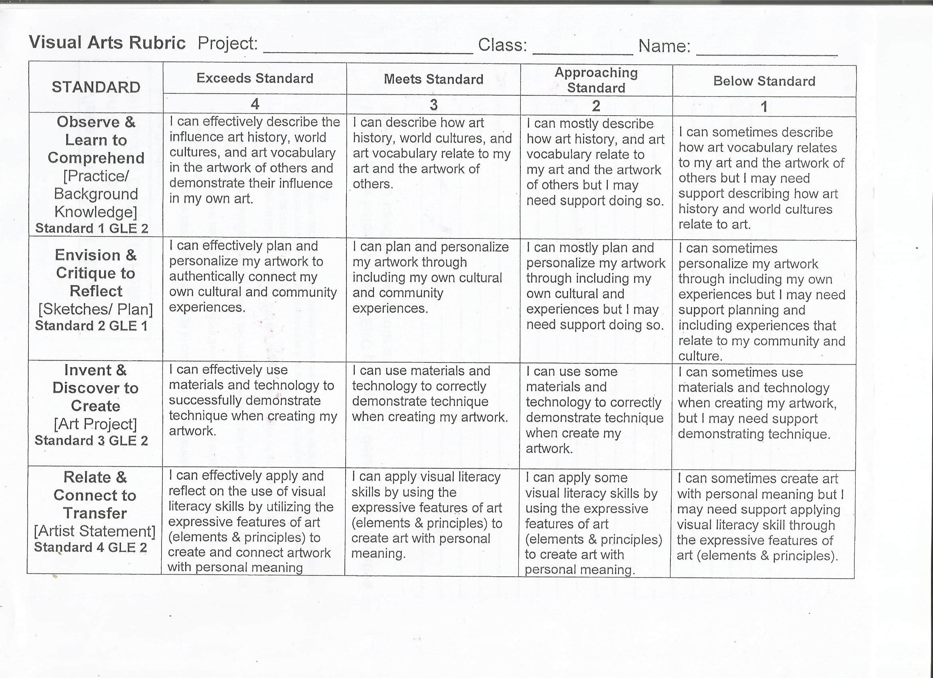  students are graded a scale from 0 to 4

Self-Reflection:
After the lesson is concluded write a brief reflection of what went well, what surprised you, and what you would do differently. Specifically address: (1) To what extent were lesson objectives achieved? (Utilize assessment data to justify your level of achievement.) (2) What changes, omissions, or additions to the lesson would you make if you were to teach again? (3)What do you envision for the next lesson? (Continued practice, reteach content, etc.)

Appendix: Include all handouts, prompts, written materials, rubrics, etc. that will be given to students.

Character Development Body Bio and Story Outline
Name: Period:

Create a Body Biography for your gnome. (write a biography in the form of a labeled drawing)

1. Draw a basic Stick figure.
2. Use the assignment guide below

Assignment: Create a “Body Biography” based on a character you want to create for your gnome.
1. The Heart: where should it be placed to best represent the character what the character loves most? What should it look like and what shape, color, pictures or symbols should be included in it?
2. The Backbone: This should be represented in a way that visually conveys what motivates the character most.
3. The Hands: What does the character do to help others or would do to help others if they could? Items that are associated with the characters either literally or figuratively should be included.
4. The Feet: on what is the character standing? This should be a symbolic representation of the character’s most fundamental beliefs about life
5. The Background: draw some elements that suggests the character’s environment, background or predicament.
6. Quotations (optional): Near the characters head include three phrases or thoughts your character might say that may further describe their personality. They could be about something they are doing, could even be a catch phrase.

Story Outline
Assignment: Based on your Body Biography fill in the outline below. This will give you a basic outline of what you can include, in your story and help get ideas down before having to write your story so you may have a better idea of what you would like to write about.
Outline Structure:
Line 1: First Name of your character
Line 2: Four traits that describe the character
Line 3: Relative (Brother, sister, daughter, etc.) of
Line 4: List three things or people your character loves
Line 5: Who Feels (three items)
Line 6: Who Needs (three items)
Line 7: Who Fears (three items)
Line 8: Who gives (three items)
Line 9: Who would like to see (three items)
Line 10: Resident of
Line 11: last name
Line 12: Quotations

Story:
Assignment: Based on the story outline and your body biography create a story about your gnome. Follow the guidelines listed below
1. Create a 1-page story, double spaced using information from outlines
2. Turn into google classroom when you are finished under the assignment labelled “Gnome Character Story”
3. The story’s HAVE to be school appropriate, anything that is inappropriate will not be accepted and will affect your grade, and call parents. You will have to rewrite your story after school or during lunch.
4. This is not meant to be stressful have fun and get creative!! There is no right or wrong when it comes to your character because it is yours!! The guidelines will help get you started and give you a framework!
5. If you have concerns or questions, please come and talk to me I am here to help you and want you to feel safe and successful!
6. Also we will not be reading these out loud, you have the option to do so if you would like too but it is not a requirement.

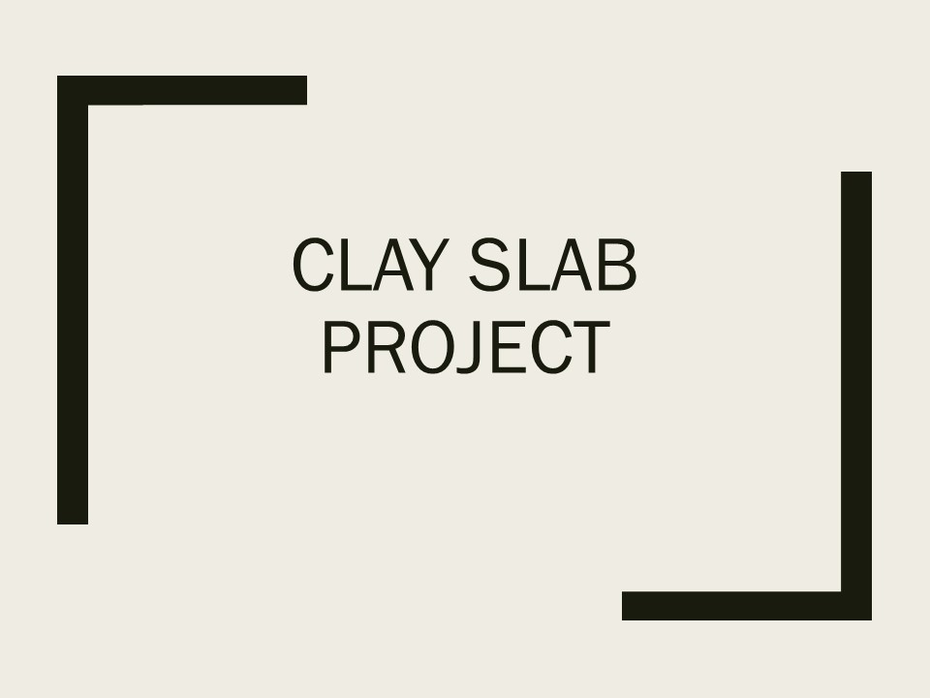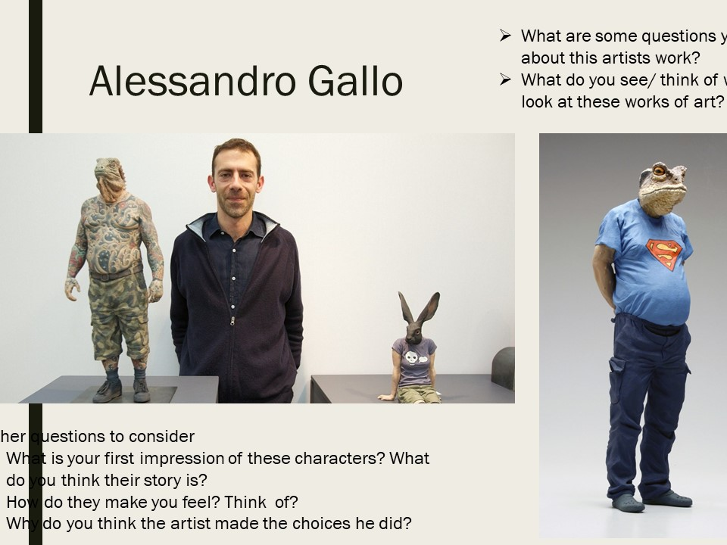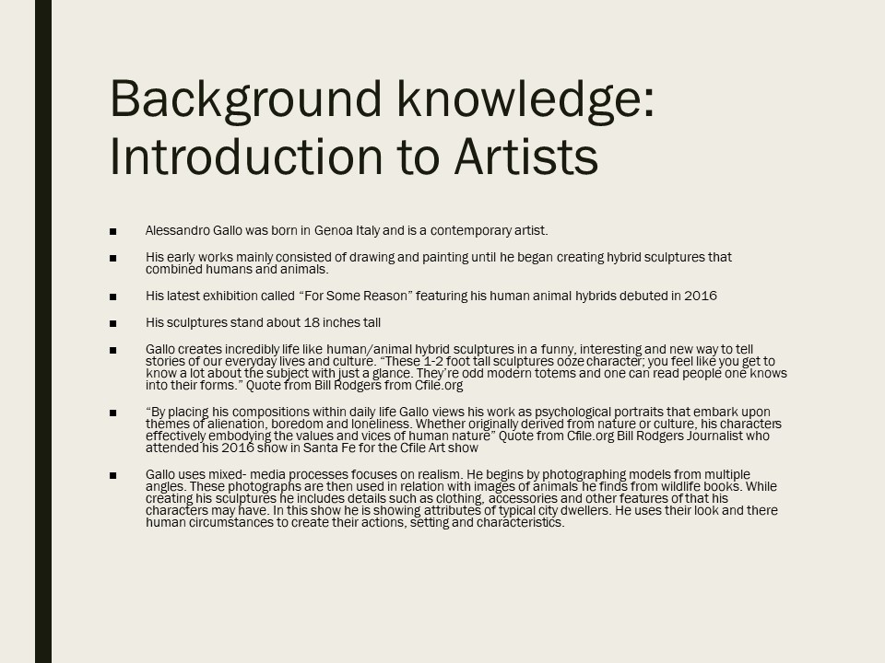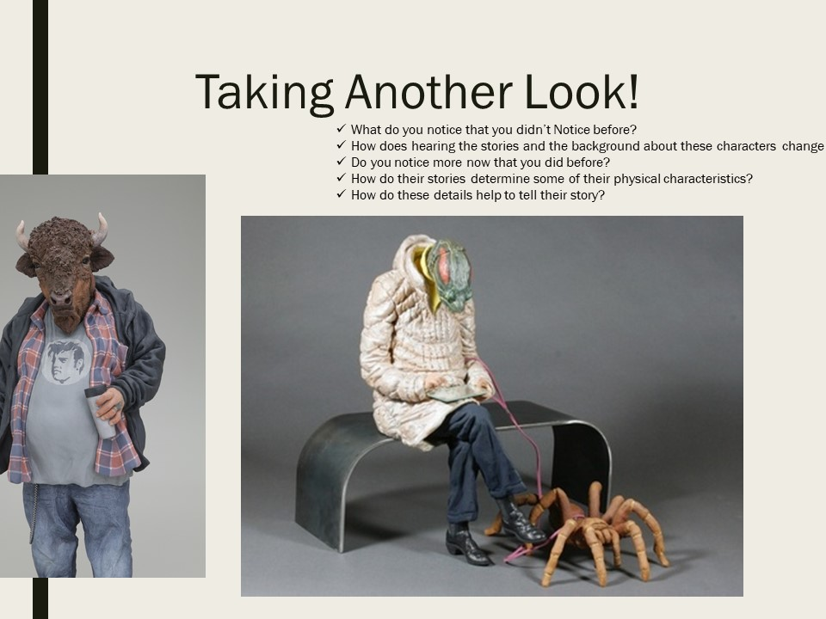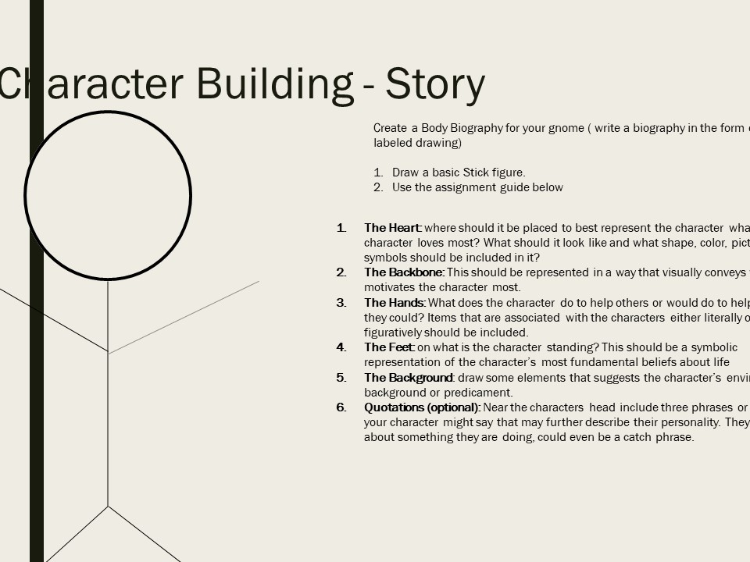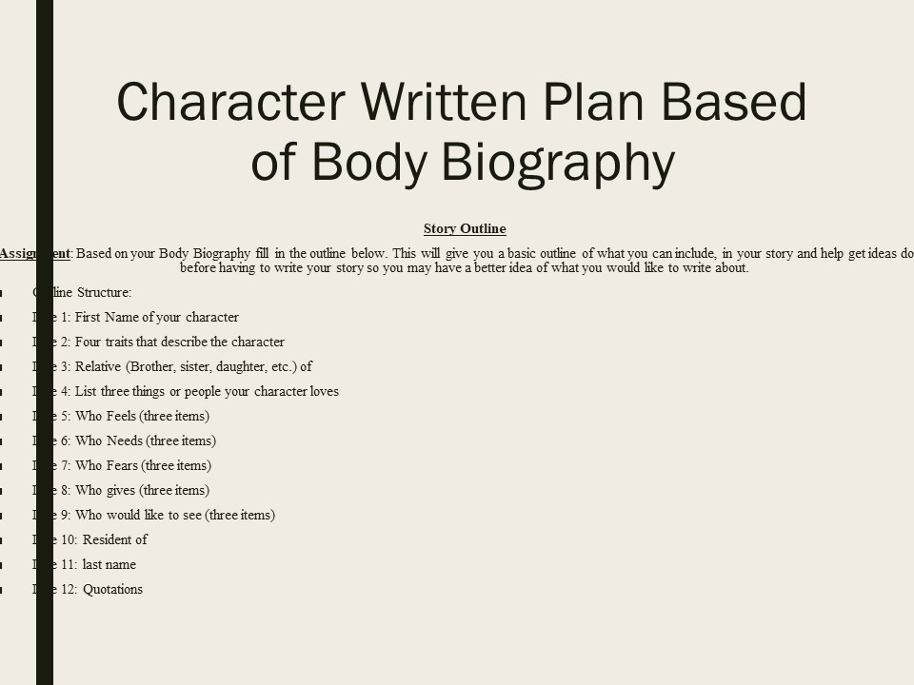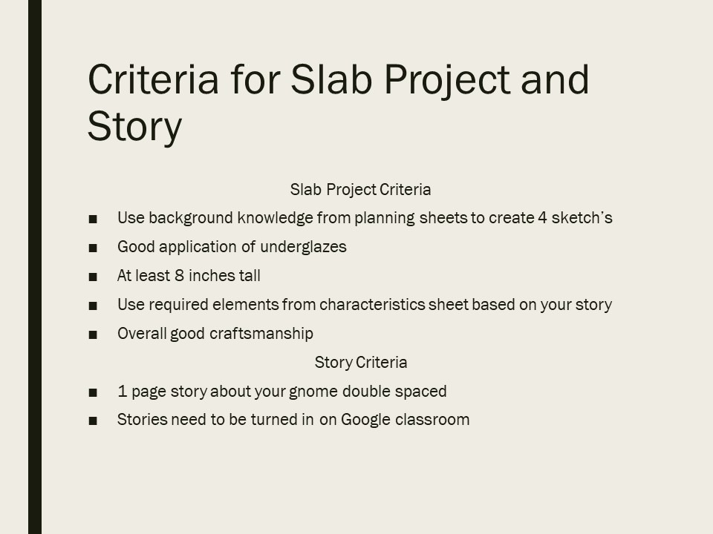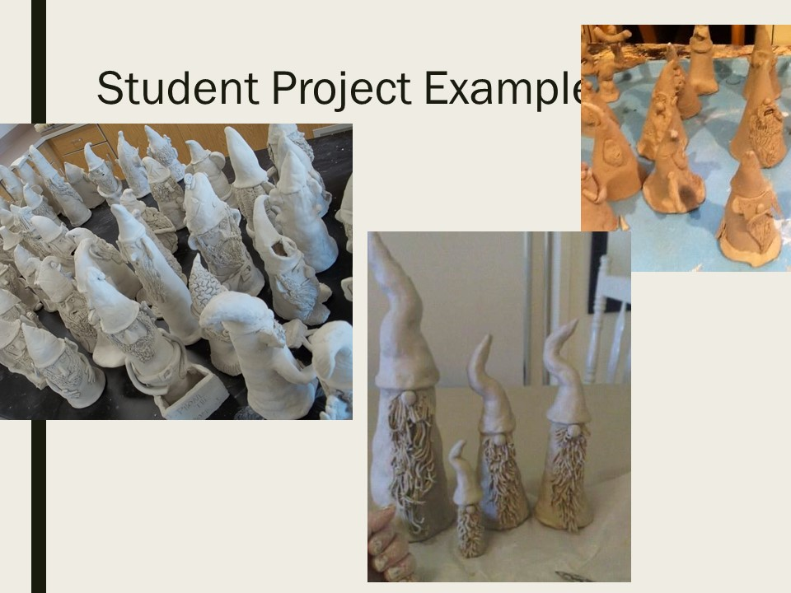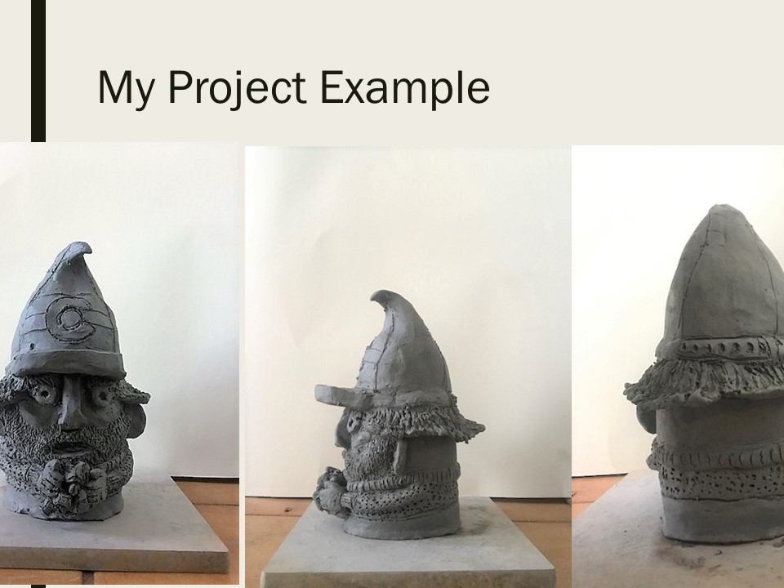

Character Building: Features Chart
Assignment: Fill out the chart below to create an outline for the features of your character based on characters personality and life. This will help you brainstorm features and ideas before you create them out of clay, so you have a direction you are going in. You must fill out the starred boxes (these are the required features the gnome must have, see criteria) the other boxes are optional.

Feature | Draw it | How to build it | Texture or color meaning (personalization)
Eyes and eyebrows

Nose
Mouth
Body Style (Short, Tall)
Expression (Emotion your character is going to convey)
Hat, Hair and Beard
Hands and Feet (what are they doing?)
Clothing
Additional Features
(freckles, wrinkles, cheeks, etc.)

Accessories (What is your character holding)

8/9/15 Fahey

