Lesson Plan Title: Endangered Animal Sculptures Length:

Note: Before you plan and write art experiences; pre-assess your students based on the proposed concepts, enduring understandings, and objectives of the unit/lesson(s). You may also gather this information from (previous) teachers, by reviewing already completed art work, consulting curriculum materials, etc., to get a better understanding of what content students already know and what they will need to know to be successful.

Pre-Assessment:
This will need to be done prior to teaching your lesson. Outline the method you will use to determine the skill/knowledge level of your students based on the concepts/enduring understandings/objectives of the lesson. (Hint: turn these into questions.) Be specific in describing what you would recognize as proficient skill/knowledge.
Questions about Animal Pictures:
What shapes do you see?
What Colors do you see?
What patterns or textures do you see?
What animal is that?
Where does it live?
What about the animal makes it able to live in its habitat?

Animal Drawings
Students will be assigned an animal according to table groups, they will be given an image of the animal and asked to draw it based on what they know about the animal and what they see. I will be able to see the students skill level of drawing animals and from there determine how to break down parts and what I need to break down and what resources I may need.

Performance:
What will students accomplish as a result of this lesson? This can be presented to students in the form of a story. In this narrative the students take on a role and create a learning product about a specific topic for a certain audience. (RAFT – Role / Audience / Format / Topic)P

- Role: Artist
- Audience: classmates and teachers
- Format: Sculpture
- Topic: Endangered Animal Sculptures

Concepts:
List the big ideas students will be introduced to in the lesson. These ideas are universal, timeless and transferrable. Examples of concepts used in art might include: Composition, Patterns, Technique, Rhythm, Paradox, Influence, Style, Force, Culture, Space/Time/Energy, Line, Law/Rules, Value, Expressions, Emotions, Tradition, Symbol, Movement, Shape, Improvisation, and Observation Look for concepts in the standards, content specific curriculum, etc.
Composition
Repetition/Reproduction
Style
Shape
Improvisions
Observations
Expressions
Movement
Technique
Collaboration
Pattern
Texture
style
influence

Enduring Understanding (s):
Enduring Understandings show a relationship between two or more concepts; connected with an active verb. The best enduring understandings not only link two or more concepts; but demonstrate why this relationship is important. Like concepts, they are timeless, transferrable and universal.
Artists can plan and use stylistic choices, various processes and techniques to make a complete and unified composition
Artists can use background and prior knowledge to create works of art
Artists can make creative decisions based on observations and understandings
Artists understand the importance of process and following steps

Standards: (All lessons should address all standards.)
1. Observe and Learn to Comprehend
2. Envision and Critique to Reflect
3. Invent and Discover to Create
4. Relate and Connect to Transfer

Objectives/Outcomes/Learning Targets:
Objectives describe a learning experience with a condition → behavior (measurable) → criterion. Aligned to: Bloom’s – Standards – GLEs - Art learning and, when appropriate, Numeracy, Literacy and Technology. Should be written as: Objective. (Bloom’s: _____ - Standard: _____ - GLE: _____ -Art learning: _____ -Numeracy, Literacy, and/or Technology)
1.Using background knowledge, literacy and visual literacy skills SWBAT answer questions, draw and identify endangered animals in Colorado.
Bloom’s: remember, Standard: Transfer, GLE 1:Visual arts respond to human experience by relating art to the community, Art Learning: ideation, Literacy: Reading, writing, talking about facts read and written, using questions and facts to transfer ideas into artwork, discussing with classmates, asking and answering questions, vocabulary, responding. Numeracy: answering numbered questions, following numerous steps, following an order, counting facial features, proportion following steps, Technology: using the smart board, interactive game, using printed images, learning facts
PGC’s
- Transfer the value of visual arts to lifelong learning and the human experience

2. Given Demonstration, examples and different tools SWBAT create different patterns, colors and 3 visible textures that resemble their endangered animal.
Bloom’s: Create, Standard: Create, GLE 1: Use familiar symbols to identify and demonstrate characteristics and expressive features of art and design, Art Learning: Inherent characteristics and expressive features, Literacy: vocabulary, Discussion, answering and asking questions, collaboration, identifying colors and patterns. Numeracy: Patterns, space, line, filling space of certain sizes, numbered steps, number of facial features, Technology: examples of animals on the smartboard and printed out, using new tools and techniques
PGC’s
- Develop and build appropriate mastery in art-making skills using traditional and new technologies and an understanding of the characteristics and expressive features of art and design
- Recognize, interpret, and validate that the creative process builds on the development of ideas through a process of inquiry, discovery, and research

3. Given Examples and Instruction SWBAT use their decorated pieces of paper and examples of the local artist Allie Ogg to make a head, eyes, nose, mouth, ears and any other specific features, glueall of their pieces on top foam and put them together to create a 3D sculpture of their endangered animal that shows individual artist and intent.
Bloom’s: apply, Standard: Reflect, GLE 1: Visual arts use various literacies to convey intended meaning, Art Learning: tools and techniques, Literacy: vocabulary, following and reading directions, discussing, collaborating, answering and asking questions. Numeracy: Measuring, using, space, form, pattern, refining, understanding size, proportions. Technology: smart board examples, handouts, artist research
PGC’s
- Recognize, articulate, and implement critical thinking in the visual arts by synthesizing, evaluating, and analyzing visual information
- Critique personal work and the work of others with informed criteria

4. Using background knowledge SWBAT reflect and discuss their process, product, use vocabulary, show individual intent and make real work connections about endangered animals in the state and their artwork.
Standard: Comprehend GLE 1: Characteristics and expressive features of art and design are used to identify and discuss works of art, Art Learning: Critical Reflection, Literacy:discussing, reading, writing, reflecting, remembering, vocabulary, asking and answering questions. Numeracy: discussing order of process, steps, patterns, size, refining, scale, proportions. Technology: smartboard, picture resources, artist research
PGC’s
- Make informed critical evaluations of visual and material culture, information, and technologies

Differentiation:
Explain specifically how you have addressed the needs of exceptional students at both end of the skill and cognitive scale. Describe the strategies you will use for students who are already proficient and need growth beyond what you have planned for the rest of the class, as well as modifications for students with physical and/or cognitive challenges. Students must still meet the objectives.

Differentiation:  (Multiple means for students to access content and multiple modes for student to express understanding.) | Access (Resources and/or Process) | Expression (Products and/or Performance)
 | teachers  students  computers  internet  pictures  handouts  Each step will be broken down into a seperate class period so that one day will focus on learning one process. Each step will demoed to the whole class and broken down step by step by either talking while I am doing a step, talking first then doing a step, asking questions, having students participate in demos such as making marks on a paper or cutting something out for me and in some instances a “I do you do”. After each step is demoed I will check in with each student and ask if there are any questions. Students will also be working in groups. Group members will work together to solve problems, help each other, share ideas and ask each other questions. Handouts with step by step instructions written and visual will be provided to students. They will also be given worksheets with ideas. I will also provide one on one support if needed. Students have the option to create more detail or add on more shapes if they would like too. They can also make the patterns as intricate as they want to example sheets will be provided. Each day we will review what we did last class and also make connections to the previous project and skills learned. Student can be simple or complex with patterns and colors. Using observation and examples they have references and again can take what they see and make creative decisions that are simple or more complex but are still successful and ,meet the learning targets. Students are all given step by step instructions plus visual and written instruction sheets that break down shapes and instruction step by step these can be followed and advanced depending on the students artistic intent and understanding. Students can use tools to make marks instead of drwing they get work with mark making and abstraction while also in the end using drawing skills | For Ideation students will answer a series of questions about an endangered animal in colorado. Using an image students will draw the animal in their sketchbook. They will also do a practice drawing after the first day that will be a practice before every step of the project  Students will create a 3D animal face using various tools and colors that they identify on the specific animal they are assigned. They use mark making and observation to fill several sheets of paper that students will then cut out the shapes for specific parts of their animal and put them together. The printing process allows for kids to explore and experiment with materials and use observation skills to make creative choices. The process is loose and experimental students are successful as long as the paper is filled and there are at least three visible textures. Colors, demos and instructions will be provided for them so they can observe and see specific colors and textures and make artistic choices based on what they see.
Extensions for depth and complexity: | Access (Resources and/or Process) | Expression (Products and/or Performance)
 | Students will become familiar with using process to get a product. They will learn and create using a variety of resources and build on previous skills learned. Students will become familiar with new methods and mediums for creating artwork and using these things to portray individual intent. Students will also be combining a variety of mediums and learn about ,different effects and possibilities. | Students will become familiar with using process to get a product. They will learn and create using a variety of resources and build on previous skills learned. Students will become familiar with new methods and mediums for creating artwork and using these things to portray individual intent. Their product will reflect their process through craftsmanship and following directions. The product will show connections between real world problems and artwork by learning background information and using images to create a like works of art with elements of such as pattern, texture and color and that reflect their own creative decision making and exploration of materials, colors and process.

Literacy:
List terms (vocabulary) specific to the topic that students will be introduced to in the lesson and describe how literacy is integrated into the lesson.
pattern
color
texture
sculpture
3D
endangered
habitat
characteristics
layering

Materials:
Must be grade level appropriate. List everything you will need for this lesson, including art supplies and tools. (These are the materials students will use.) List all materials in a bulleted format.
- Foam paper
- drawing paper
- scissors
- hot glue
- elmers glue
- tempera paint
- fine tip and large tip sharpies
- handouts
- paint brushes small and large
- paper plates
- water buckets
- paper plates
- tag board pieces
  - 8 x 10 in
  - 7 x 5 in
  - 4 x 2 in
  - 10 x 3 in
  - 10 x 4 in
  - 2 x 5 in
  - 3 x 10 in
  - 4 x 10 in
- various tools: coosh ball ring, forks, sponges, bottle caps, Q-tips, marker caps, styrofoam cups, toothbrushes, tin foil (nine plates set up with each one of these tools-- one per table group)
- egg cartons for paints
- paint colors: brown, magenta, yellow-orange, magenta-purple, black, white, blue, purple, orange, yellow (nine egg cartons full of paint--- one for each table group)
- reference images
- teacher examples

Resources:

List all visual aids and reference material (books, slides, posters, etc. Be specific; include title, artist, etc. Make reference to where the material can be found. (These are the resources used by the teacher to support/develop the lesson.) List all resources in a bulleted format.
- Information about animals
- Animal images on the smart board
- question sheets
- handouts of patterns, animals and how to draw
- group members and classmates
- teachers
- internet or computers in the classroom or in the computer lab
- supplies in the classroom

Preparation:
What do you need to prepare for this experience? List steps of preparation in a bulleted format.
- cut out shapes for the animal parts (paper and foam)
- make handouts
- make examples sheets and questions sheets
- make cards for scoot game
- make examples
- smart board presentation

Safety:

Be specific about the safety procedures that need to be addressed with students. List all safety issue in a bulleted format.
When using scissors walk, do not run, do not cut anything other than your paper, cut away from yourself and others.
Do not eat or sniff glue, ink, markers or any other media used.

Action to motivate/Inquiry Questions:
Describe how you will begin the lesson to stimulate student’s interest. How will you pique their curiosity and make them interested and excited about the lesson? What inquiry questions will you pose? Be specific about what you will say and do to motivate students and get them thinking and ready to participate. Be aware of the varying range of learning styles/intelligences of your students. Some ideas might include: telling a story, posing a series of questions, role-playing, etc.
What shapes do you see?
What Colors do you see?
What patterns or textures do you see?
What animal is that?
Where does it live?
What about the animal makes it able to live in its habitat?
Where does your animal live?
What Color is it/ What does it look like?
Why is it endangered?
What are some colors and textures you notice?
What tools can we use to make certain textures?
What happens when you mix these colors?

Ideation/Inquiry:
Ideation is the creative process of generating, developing, and communicating new ideas, where an idea is understood as a basic element of thought that can be visual, concrete or abstract. List and describe inquiry questions and processes you will engage students in to help them develop ideas and plans for their artwork.
What are colors, patterns and textures?
Where do we see these in these animals?
Where have you seen or used these elements in your own artwork?
How did you use them?
What did they add to your artwork?
Why did you use them there?
What are some patterns you like?

Instruction:
Give a detailed account (in bulleted form) of what you will teach. Be sure to include approximate time for each activity and instructional methodology: skills, lecture, inquiry, etc. Include motivation and ideation/inquiry where appropriate; including what student will understand as a result of the art experience

Day 1 | Instruction - The teacher will... (Be specific about what concepts, information, understandings, etc. will be taught.) Identify instructional methodology. KNOW (Content) and DO (Skill)  Art 1-Purple Day  DAY 1  Pre-Class Setup  - Animal Images set up on the smart board  - mexican spotted owl  - lynx  - kit fox  - wolverine  - grey wolf  - grizzly bear  - Popsicle sticks labelled with animals in a hat or bowl  - hat or bowl set out on the middle table  - Scoot cards at the center table along with question sheets  - paper images of animals on the carpet under the smartboard with drawing paper  - teacher examples  - write learning targets  Start class  1.Go out in the hallway and greet the class  - Ask the soar leaders to walk into class first and grab tokens (2 students)  - after about 10 to 5 second the class comes in after and quietly sits in their table groups  - ask students how they are doing for the check in for the day  2.Go over schedule  - Talk about animals  - You will get assigned an animal  - we will play a game to learn about the animal  - drawing animals  3. Show the animal images on the smart board  - ask questions  - what is an endangered animal?  - what animals are these?  - what colors and textures do you see?  - where do they live?  - What features help them live in these places  - What shapes do you see that could maybe help you draw a animal?  4. one group member draws a popsicle stick from a hat that will have the animal they are using to create their project  - Write down table color and have students write down their names under the animal on the list  - ask students if they have any questions?  5. Play the scoot game to learn facts about their animal  - students will be given a question sheet to write their answers on  - Students will write name, class and animal on the top  - students will touch their noses or hands in lap when they are done  - Scoot cards will be distributed throughout the room  - Facts (answers to the questions) will be written on a small piece of paper  - the paper will be face down on the table  - The students will stay in their seats until until I say Scoot  - I will demonstrate how to do this  - We will do one practice round  - each student will move one spot over to the right  - students will then flip over the piece of paper and see if the paper has the answer to one of the questions about their animal  - If the card does not have a fact about their animal they will turn it back over and remain in that spot until time is up  - If the card does have the answer to their question students write the answer down under the correct question  - A timer will go off after about 30 seconds once students hear the timer they move one spot over to the right again  - if a student moves before the timer goes off they skip a turn and have to stay there until the next scoot  - This process repeats until every person has all of their questions answered  - If a student finishes all of their questions they will return to their table  - Once everyone from their table group is done they will answer the last question which I will hand out the students at the table will have until the end of the class to work on the last question: Drawing their animal  - The first table group to finish all four questions wins soar tokens  - At the end of the game I will collect cards and all students will be drawing their animal on their question sheet  6. Work Time for drawing  - Students will continue to draw their animal until the end of class  - I will pick up all of the scoot cards  - I will walk around monitor, ask and answer questions, pre assess drawing and literacy skills  - ask students what they through of the game if they liked it/ learned something  - If students finish before class time is over each group will present their answers to their questions to the class  - If students do not follow directions students will get a refocus and have to sit out for the rest of the game or sit out for the rest of the game and their table group will be unable to win  7. Clean up  - put question sheets on the center table (the grey table)  - Make sure names and class are on them  - put away any markers or pencils used  - Soar leaders call up quiet and cleaned up tables  WEEDIN- DAY 1 REFLECTION  The students seemed to like the game and were very excited to learn about animals! Weedin’s class is higher class and they seemed to understand and write down the questions I modified the game so that kids could work with a partner or in a group of three in case kids were struggling with reading and writing. At the beginning I set up the lesson that we were Wildlife Activists and were going to help save the endangered animals in Colorado using our artwork! This got them excited and now each group is a team and must work together to save their animal! However the lesson was a lot shorter than I thought and the kids had more free time than I wanted for next class I think I am going to make sure to have an extra activity in case the lesson goes quickly again.  MIEHE- DAY 1 REFLECTION  Reflection: This class took longer to complete the scoot game so we had less time to draw and did not need the extra activity. This group loves to move around and really enjoyed being able to get and move for the game. there were some problems with some kids thinking others were cheating so for next time I will be sure to assign them spots before the game starts so I know what order they go in. For the next class instead of demoing the pattern sheet before I will stop and make sure most of the class in done with their drawings and demo at the end. I noticed that demoing this at the beginning caused students to rush through their drawings so they could get to the pattern practice sheet.  LEATHERMAN- DAY 1 REFLECTION  Again this class seemed to really enjoy the activity. However I would like to change the game so that their can be an actual winner. It was mainly a game of luck and next time I would like to do something where they actually had to problem solve as a team. I would also like to leave time to review the answers at the end to make sure everyone had them all written down. This class by far went the best and I felt the most comfortable.  DAY 2  Pre-Class set-up  - Make sure paper parts are cut and set in boxes labelled  - pour paint for each part of animal  - Teacher examples and demo sheet are out on the center table  - paint brushes and tools set out on center table on plates  - paper plates set out for mixing paint  - Water buckets full and by the sink  - Lay out questions for review on center table  - write learning targets  - Put up smart presentation of animals  Learning Targets  🎯I can use different tools and paint to create textures for all the different parts of my animal  - I can use at least three different tools on each part  🎯I can use my background knowledge and pictures to create the colors of each part of my animal  - I can mix colors  Start Class  1.Go out in the hallway and greet the class  - Ask the soar leaders to walk into class first and grab tokens (2 students)  - after about 10 to 5 second the class comes in after and quietly sits in their table groups  - ask students how they are doing for the check in for the day  2.Go over schedule  - We will review what we learned last class  - Talk about our animal facts  - Demo on how to paint our animal parts  - Work Time  3. Review Facts Game  - On the middle table have questions stacked up in a pile for each animal--- plus bonus questions  - pass out questions sheets with answers from the scoot game and pass out animal picture sheets  - I tell students the rules and talk about the bonus questions that they will be about a different animal so they need to be listening  - There will also be prizes at the end jolly ranchers for the winning team (I will give them out at the end of class)  - Each group comes up with a word that means they are done talking about the answer of the question  - Call on one student in the group to pick a question  - Teacher reads the question  - The group that was given the question talks with each other to find the answer  - When they are done they say their word  - I call on the student to answer the question in the group  4.Demo painting  - Show students different boxes with animal parts (each part in the box will be labeled ears, nose, face)  - grab one of each part from one box to demo with  - Have an animal picture in front and talk about the colors that will be used  - Grizzly Bear face- Brown, White, maybe black, yellow and purple  - Wolf Face- black, brown, blue, yellow, orange  - Owl face- yellow, brown, orange, blue  - fox face- yellow, brown orange, blue  - White will be on a seperate plate at all time for mixing and used as a community plate for tints  - noses- Black and grays  - beak- yellow  - Wolf Ears- grays  - Fox ears- brown, orange, pink  - bear ears- brown and orange  - wolf top on the nose-yellow, orange, brown  - fox top of nose- brown, yellow orange  - owl mask- blue, brown, yellow  - show how to create textures using paint brushes and different tools  - marker tops  - bottle tops  - straws  - q-tips  - tin foil  - paper towel tubes  - paper  - fork  - paint brush  - toothpicks  - show layering and how you can mix colors on the table and put them on top of eachother  - Show them how to mix with white and how it can make colors lighter (the blue cannot be mixed with white) they can make many different light colors using white from one color  - in order to put lighter colors on top of darker colors you must wait for them to dry a little more  - show white highlight and white on the back of the paint brush last after paint has had a chance to dry  - Show how to layer textures with different tools  - talk about how each part must have at least three different tools used before moving on  - Once they are done with one section students can move onto the next the colors may be switched out  - Ask students if their are any tools they would like me to show textures for  - For students who ask to see have them come up and try the tools or throughout the demo call on students who may not be paying attention and have them ma7.ke some prints with tools  - Model cleaning instructions  5.Work Time  - make sure students have messy mats and pass out tools and paper  - They cannot have paints until their name and class are on the back of their paper  - Model their class letter and number  - Once names are on paper pass out paints  - check for understanding  - monitor room  - answer and ask questions  - help if needed  - Check progress  6.Clean up  - Stop class  - Call on a volunteer to come up and model where things go  - Plastic tools go into the sink in the blue bucket  - Brushes go into the bubbly bucket  - Styrofoam cups go on the messy mat on the center table  - styrofoam plates left in the sink  - Messy mats go back to the box in the front of the room  - Projects go on the small drying rack (make sure your name is on them)  - I will collect egg cartons with paint  - After this has been modelled have the students repeat where things go  - As students clean monitor the sink and gather up paint containers  - Have three students sponge off tables make it clear that I will give out the sponges  7.When Tables are clean soar leaders go up to the front of the room and turn off the lights  - As they call quiet and clean tables I will pass out jolly ranchers to the class and the winning team can have jolly ranchers and a soar token  DAY 2 REFLECTION- MIEHE  The game was fun and the students really enjoyed it however I am going to narrow in down to only two questions, a bonus question and give students a time limit. The game took to long so I felt like I was rushing through the demo and the students did not have much time to work.  DAY 2 REFLECTION- BRUNTZ👌  The kids really loved the printing and they enjoyed the game however the game and the demonstration took to long and the students had a limited amount of time to work. For the next class the game needs to be shortened so that the students have more time to work on the project. This class fif very well when instructions were repeated and students were able to participate in the demos. The clean up went very smooth. Next class I will also have to address layering for their background and that we will are not making the form of out animal we are filling in the whole piece of paper. We did seem to meet our learning targets for the day.  DAY 2 REFLECTION- LEATHERMAN 💣  I shortened the game for this class, this class however has some lower students and a lot of students who had trouble holding focus for a long time. When demoing with this class have restless kids be helpers and speak positively towards them with a light and friendly tone. Keep demos short and give more individual instruction. Next class the same thing needs to be addressed as far as layering and not drawing our animals. For this class when using painting materials I need to allow at least 15 minutes for cleanup or come up with a new clean up strategy. They struggle with cleaning up.  DAY 3  Pre-Class Set-Up  - Make sure paper parts are cut and set in boxes labelled  - pour paint for each part of animal  - Teacher examples and demo sheet are out on the center table  - paint brushes and tools set out on center table on plates  - paper plates set out for mixing paint  - Water buckets full and by the sink  - Lay out questions for review on center table  - write learning targets  - Put up smart presentation of animals  Learning Targets  🎯 I can finish creating the different parts of my animal  - Use at least three different tools for each part  - Fill my entire paper  - Use different layers  🎯 I can make different patterns  Start Class  1.Go out in the hallway and greet the class  - Ask the soar leaders to walk into class first and grab tokens (2 students)  - after about 10 to 5 second the class comes in after and quietly sits in their table groups  - ask students how they are doing for the check in for the day  2.Go over schedule and learning targets  - Tell students the learning targets for the day  🎯 I can finish creating the different parts of my animal  - Use at least three different tools for each part  - Fill my entire paper  - Use different layers  🎯 I can make different patterns  2. We will do a short review  3. Short demo on other animal parts  4. Work time  3. Short Review demo  - Call students up by quiet tables to circle around the center table  - review last class  - started printing  - ask students:  - How many layers do we have to have?  - What are we making?  - What are we looking for?  - talk about layering ( using three tools- one for each layer )  - go over mixing colors  - talk about using my paper plate for mixing colors and using popsicle sticks in my paint to transfer colors onto my plate  4. Demo new steps  - Talk about the different parts of the animals  - go over and have students identify the different parts of the animal  - ask students about the colors on the nose, beak top of nose, inside of ears, mask of owl, feathers and the head  - compare the colors of the different parts and talk about using the colors we SEE in each part  - demo those colors in another part besides the head and show example  - Talk about when you are done with each part  - write your name and class on the back of the next part  - show one other person in your animal team and me before moving onto the next part  - I will give out the parts when students are done  - put that part on the drying rack  5.Work Time  - students get messy mats  - I have one SOAR leader pass out paper plates and the other one pass out projects  - Once students have their messy mats out students can grab their tool plates ( one per table)  - I will give them their paints  - Monitor the classroom  - see if students are meeting learning targets  - give individual instruction if needed  - help students  - answer and ask questions  - give suggestions  - check in  - check artwork  - pass out other animal parts  6.Clean up  - Stop class  - Call on a volunteer to come up and model where things go  - Plastic tools go into the sink in the blue bucket  - Brushes go into the bubbly bucket  - Styrofoam cups and Q-tips go on the messy mat on the center table  - styrofoam plates left in the sink  - Messy mats go back to the box in the front of the room  - Projects go on the small drying rack (make sure your name is on them)  - I will collect egg cartons with paint  - After this has been modelled have the students repeat where things go  - As students clean monitor the sink and gather up paint containers  - Have three students sponge off tables make it clear that I will give out the sponges  7.SOAR leaders turn off the lights and call up quiet and clean tables  Weedin- Day 3 Reflection 👌  Students did really well with the printing and observing colors and patterns on their animals.Some of them finished their head but most of them did not. There will need to be another day of printing. Once they got through the head and moved to the other body parts they went fast. We should only need one more day. Jason and Finn took a really long time on their head and I will need to help them with moving along on the other features of their animal.  Bruntz- Day 3 Reflection👏  Most students finished the head of their animal and a good majority started on the next features of the animal. Students will be done with all of the features by next class. This class also cleaned up very fast and work very fast.  Leatherman- Day 3 Reflection🙌  Students stayed engaged today and were successful with making textures and they met the learning targets for the day. However only a few students started on their other features but most of them were still working on their heads. I also did a lot more showing and this seemed to help with understanding Next class I will have to push students to finish and make sure they are all done with their features by next class. The class was much better today. I used strategies for Ethan and Gavin and they seemed to work really well. Jacob is almost done with all of his features so next class for those kids who are almost done I will have to have an extra activity. I also allowed more time for clean up and that seemed to work really well. Also positive feedback and reinforcement really helps the students in this class.  DAY 4  Pre-Class Setup  - Make sure paper parts are cut and set in boxes labelled  - pour paint for each part of animal  - Teacher examples and demo sheet are out on the center table  - paint brushes and tools set out on center table on plates  - paper plates set out for mixing paint  - Water buckets full and by the sink  - Lay out questions for review on center table  - write learning targets  - Put up smart presentation of animals  Learning Targets  🎯I can finish my features for my animal using different tools  - Use at least three different tools  🎯I can identify patterns and colors on my animal  - Use colors and patterns I see on my animal  Start Class  1.Go out in the hallway and greet the class  - Ask the soar leaders to walk into class first and grab tokens (2 students)  - after about 10 to 5 second the class comes in after and quietly sits in their table groups  - ask students how they are doing for the check in for the day  2. Go over schedule and learning targets  - Ask students what we did last class  - Go over learning targets  🎯I can finish my features for my animal using different tools  - Use at least three different tools  🎯I can identify patterns and colors on my animal  - Use colors and patterns I see on my animal  3.Short Review  4. Work time  3. Short Review  - Tell students we will be printing on other features today  - show students where the features are labelled on center table  - grab one piece from each animal  - walk up to the smart board and show the features on the animal  - ask students what colors they see?  - Tell them they will be looking for colors and patterns for each part of their animal  - talk about each part  - tell them the eyes will be one solid color either blue or green  - they need at least three different textures for each  - every time they finish a texture they will put it on a piece of paper with their name on it also write their names on the back of each piece  4.Work time  - dismiss students by quiet tables to come up and grab the next part of their animal  - monitor classroom  - answer and ask questions  - help students  - check work  - check for understanding and meeting learning targets  - give students paint for the eyes  - this will be set up on the center table only  5. Clean up  - Stop class  - Review where things go and ask students  - Plastic tools go into the sink in the blue bucket  - Brushes go into the bubbly bucket  - Styrofoam cups and Q-tips go on the messy mat on the center table  - styrofoam plates left in the sink  - Messy mats go back to the box in the front of the room  - Projects go on the small drying rack (make sure your name is on them)  - I will collect egg cartons with paint  - After asking have the students repeat where things go  - As students clean monitor the sink and gather up paint containers  - Have three students sponge off tables make it clear that I will give out the sponges  6..SOAR leaders turn off the lights and call up quiet and clean tables  Weedin- Day 4 Reflection💥  We had a short day today due to a schedule change however it most of the students finished one or more of their features in 20 minutes. They all seemed to the learning targets as far as looking at colors and textures on the animal parts. However some of them were slightly confused still about what they were looking for so during demonstration I may need to show all of the different parts and let them know which ones they will be making. I also need to reorganize the templates for the parts into seperate bins and label them in order and by part so students know which one they are working on and what they need to be observing on their animal. Numbering them or will also help me keep track of who has done what.  🎨 does not speak very good english and has been gone for a couple class periods I may need to modify to letting him only use one tool for the facial features and let him use what he has for the face which I think uses two tools. When instructing point to things while speak and walk to show for cleanup and supplies.  Miehe- Day 4 Reflection 💫  Today students were a little antsy and although they worked they had some trouble staying on task and following directions especially during clean up. Most of them However did get almost all of their features done they just have to finish making their eyes. Some still had trouble understanding that we need to fill the whole paper with prints and different textures that are noticable. For the next class I may just have students repeat this and show some students examples from other classes. All in all the students were meeting the learning targets and observing colors and patterns on specific features of their animals.  Bruntz- Day 4 Reflection👍  Today students did really well and majority of them finished all of features. There are a few students who still did not get enough textures and still claimed they were done so next I will have to address this and talk to those students. Students were looking at the animals for colors and textures and making marks and choices based on what they saw. This class moves fast and as of right now is a head of the other classes.  Leatherman- Day 4 Reflection💫  Today's class went pretty well most of the students completed almost all of their pieces. For management purposes for this class I had students who were completely done be helpers for kids who were not. This seemed to work well for some of the students who have trouble staying on task or are struggling with what to do or move slow. Most of the students met the targets for the day and like I said completed all of their animal parts.  🎨 was able to get all of his animal pieces done with help from another student he did really well for the most part as far as following directions. He loves helping and positive feedback really helps him.  🎨 was able to finish some of his animal parts but I had to sit down with him one and one and help him stay on task. I found out he loves cooking and mixing things together. We associate this with color mixing and he got really excited and this helped with his motivation to work. He is also knows what to mix to get what result when working with colors.  🎨 has been having quite a few issues and apparently has been acting out a lot. He did not get anything done in class, I may have to sit down with him next class and make sure he stays on task.  DAY 5  Pre-Class Set-Up  - Make sure paper parts are cut and set in boxes labelled  - pour paint for each part of animal  - Teacher examples and demo sheet are out on the center table  - paint brushes and tools set out on center table on plates  - paper plates set out for mixing paint  - Water buckets full and by the sink  - Lay out questions for review on center table  - write learning targets  - Put up smart presentation of animals  - `get out examples of how to draw the animals  have shapes ready and labelled so students know which what to draw on what sheet of paper  11. make folders, label and grab parts of the animals that students are missing and sort them  12. have shape reference sheets ready  13. Get out Template Sheets  Learning Targets  🎯I can draw and cut out pieces for my animal  🎯I can finish adding color and line patterns  - at least two colors and 1 texture  Start Class  1.Go out in the hallway and greet the class  - Ask the soar leaders to walk into class first and grab tokens (2 students)  - after about 10 to 5 second the class comes in after and quietly sits in their table groups  - ask students how they are doing for the check in for the day  Go over schedule  - Learning Targets  🎯I can draw and cut out pieces for my animal  🎯I can finish printing  - at least three textures on each piece  2. Short demo on how to draw  3. Work time  Demo  - Have students gather around the center table-- have materials ready at the center table instead of the light table--- move kids around as needed  - If students are messing around during the demo they will be sent back to their seats  - Start by asking the students  - What shapes do you see in your animal?  - use the smart board pen to highlight and label these pieces as we go  - Turn to the document camera and show the students the project example and point the 4 different parts that we have been working on  - Show students their how to draw sheets and choose one to show them how to follow the steps and make their shapes  - go down the sheet and do each step on each part of the animal under the document camera  - Show this on a practice sheet of paper (to show what it will look like as a whole)  - Then show how to translate it the separate parts that will then be put together  - Show examples of all of the animals and what they will look like when put together  - Emphasize that the parts have to be large especially for the head they should fill the entire piece of paper-- make connections to the size of faces-- if this is a mask it should fit over our faces  - Also show the template examples of each animal and talk about the size  - Tell students when they are done drawing they have to check with one other class mate and the teacher that they have a big size and they are using the right piece.  - After the student has checked with the student and the teacher I will give them scissors they cannot cut until they have been checked.  - Emphasize that the students need to draw on the back of their paper and that it is ok that their is paint on the back you can still see the pencil marks.  - Make connections to the previous project where they made snow angels. When they used pattern paper they drew on the back so you can’t see pencil marks.  - While going through the steps also read the steps written on the sheet and the name of each part  - while showing each part read the name written on the back of the paper and say double check which part it is before drawing and especially cutting  - When showing the eyes and the ears talk about their previous project and ask how they made something the same shape and size when cutting?  - Show folding and draw the shape on the back of the colored part, fold paper and cut.  - Tell students if they have white paper they need to cut out all of their animal parts out first  - Let students know that they have to finish drawing on all of their papers before they can begin adding color to their pieces  - Ask if there are any questions  - Aks review questions  - How many textures should I have?  - When can I finish printing?  - Have this written down by the learning targets-- I can print when I have cut out all of my pieces!  3. Work time  - pass out drawing guide sheets and animal example sheets  - monitor classroom  - answer, ask questions and check for learning targets  - help students  4.Pastel and tempera cakes demo  - Call over students who still have animal parts to paint (students who are done can keep working)  - first talk about how we will still be observing out animals for colors and textures but we will be using tempera cakes and oil pastels instead  - First make some line marks and patterns and explain that the we will be using line patterns only to make marks  - make at least two different line patterns  - Then use two colors of tempera paint on the same paper and let students know they have to use a total of two colors  - For their eyes however they will be using the blue or green paint we used before ao when they are ready for that step they need to let a teach know  - Let kids get back to work show them that the tempera cakes are on the back table and the pastels on the middle table  5.Foam and sharpie demo  - For students who have already finished painting all of their parts call over to the middle table  - show students how to outline shapes in sharpie and draw their eyes  - Show students how to trace the outline of their animal onto their foam sheet, cut out the shape and glue their piece on  6..Clean up  - For students who printed put tools in the blue bubbly bucket, leave the styrofoam plates in the sink and I will collect paint trays  - Students put their painted pieces on a piece of paper with their name on it. ( I will put this on the drying rack)  - Students put all of their cut out pieces and their scraps inside of their folder and put them on the center table  7.SOAR leaders call up quiet and clean tables to line up  Weedin- Day 5 Reflection👌  This class is a little behind and most of them were able to cut out all of their shapes today. There are still a good majority of students who need to finish printing though. Also most of the students were successful however some of the students did not know which part was which and one student made their head to small another students cut his up completely so we will have to piece it together next time, For next class label parts of the animal for the students before class and emphasize that the head includes the ears and the chin and for the owl make to cut our as a whole instead of two separate circles.  Miehe- Day 5 Reflection👌  We has a shorter class today so we did not get to accomplish as much as I was hoping. However I made new example sheets that have the sizes and the visual of what should be on each section. I also arranged all of the pieces in boxes with visuals and labels so that the students can find them and know which is which. I also made connections to the size of our faces so students know that if they are making a mask it needs to be big enough to fit over our faces. I went through every example sheet thoroughly. The students did really well this class and were all met the learning targets. They all had the right sizes and were drawing on the correct features. For next class I am going to write down that we will be painting after all of the pieces are done! I will also demo clean up for next class.  Leatherman- Day 5 Reflection👌  Most of the students finished drawing and started cutting out their shapes and some even began to use sharpie to outline their shapes and make their eyes. Instead of using the tools and tempera paint students used tempera cakes and pastels to finish their pieces. most of them also finished painting their pieces. Overall they met the targets for the day and were all making the correct sizes and even putting pieces together. For the next class I am going to split up the demonstrations.  Bruntz- Day 5 Reflection🙌  Most of the students were already finished with all of their pieces so I demoed finishing pieces with tempera paints and pastels to the students who were not done. This worked well since there were only a few and the other kids were able to start working sooner. This class moves very fast and they are a head of the other classes. Some of the students even finished their masks today and most of them have started gluing and cut out foam pieces.  Day 6  Pre Class Setup  - set out teacher examples, messy mat, water bucket, tempera cakes, brushed black and white pastels, paint brush, foam, and teacher class example on the center table  - Set out students projects  Learning Targets  🎯I can draw and cut out pieces for my animal  🎯I can finish adding color and line patterns  - at least two colors and 1 texture  🎯I can can glue foam on the back of all of my animal parts  - Glue all of my pieces together  Start class  1.Go out in the hallway and greet the class  - Ask the soar leaders to walk into class first and grab tokens (2 students)  - after about 10 to 5 second the class comes in after and quietly sits in their table groups  - ask students how they are doing for the check in for the day  2. Go over the schedule for the day and learning targets  - Learning Targets  🎯I can draw and cut out pieces for my animal  🎯I can finish adding color and line patterns  - at least two colors and 1 texture  🎯I can can glue foam on the back of all of my animal parts  - Glue all of my pieces together  2. Show artist images  3. Short Demo  3. Show Allie Ogg Art  - Tell students she is a local artist and she has art all over old town  - Ask what they notice about our masks and her cardboard creatures? How are they similar?  - She is the inspiration for our artwork!  4. Short Demo  - Show students my example  - ask which parts they see foam on?  - How do you think I get the same shape as my drawings?  - Before showing how to add foam use eye examples and show students how to outline eyes with sharpie and add pupils  - they can look at the example at the table for reference  - compare eyes to how Allie Ogg makes hers  - Take teacher example and show how to trace animal parts onto the foam  - let students know to trace in pencil only  - Emphasize that they need foam under all of their parts  - Once they have cut out foam they can start to glue things together  - Let students know they cannot use foam until they have finished cutting out all of their parts and adding color to them.  5. Work Time  - Monitor classroom  - answer and ask questions  - check for understanding and meeting learning targets  - get foam for students who are ready to start  - help students  6. Clean up  - Put all of the pieces in the their folders and paper clip together if needed  - anything with glue goes on the drying rack  - place folders on the middle table  - put messy mats away  - brushes in the bubbly bucket  - wipe down tables of needed  7. SOAR leaders call up quiet and clean tables  Weedin- Day 6 Reflection👏  Today went well students met the learning targets for the day and about four students finished completely and about 4 were close to finishing. There was some confusion on the painting part most students just used one color to paint so next time I will have to emphasize this. Also I need to emphasize and demo that all of the pieces have to have foam or felt under them. I should also show students how to use sharpie on the eyes during the demo.  Miehe- Day 6 Reflection 👏  Today students met the targets and this class seemed to move very quickly. About three students were able to finish completely and several others were completely finished with their pieces and had already started cutting out their shapes and gluing them together. For this class I really emphasizes using the pastel and introduced the sharpie for the eyes this worked very well because kids pieces in this class had way more texture.  Leatherman- Day 6 Reflection👌  Today went well most of the students started on foam and some were able to finish the project almost all of the students are done painting all of their pieces. There are only about three students who need to finish painting the rest have started cutting or gluing.  Day 7  Pre Class setup  - set out teacher examples, messy mat, water bucket, tempera cakes, brushed black and white pastels, paint brush, foam, and teacher class example on the center table  - Set out students projects  - Set out foam  Learning Targets  🎯I can finish my animal mask  - 5 pieces  - all of my pieces are glued on foam  Start Class  1.Go out in the hallway and greet the class  - Ask the soar leaders to walk into class first and grab tokens (2 students)  - after about 10 to 5 second the class comes in after and quietly sits in their table groups  - ask students how they are doing for the check in for the day  2.Go Over learning targets and schedule  Learning Targets  🎯I can finish my animal mask  - 5 pieces  - all of my pieces are glued on foam  - Work time  - Briefly review last class ask students if they have to have foam under all of their pieces?  - How many pieces should they have?  - if they are not finished painting that needs to be done first  2. Free choice if they are finished  3. Work time  - Monitor classroom  - answer and ask questions  - check for understanding and meeting learning targets  - get foam for students who are ready to start  - help students  - check for progress and push students who need to finish  Clean up  - put masks on the small drying rack from bottom to top  - place folders on the middle table  - put messy mats away  - brushes in the bubbly bucket  - wipe down tables of needed  7. SOAR leaders call up quiet and clean tables  Day 8  Pre Class setup  - get out critique sheets and projects  Learning Targets  🎯 I can talk about my classmates artwork  🎯I can talk about my artwork  1.Start Class  1.Go out in the hallway and greet the class  - Ask the soar leaders to walk into class first and grab tokens (2 students)  - after about 10 to 5 second the class comes in after and quietly sits in their table groups  - ask students how they are doing for the check in for the day  2.Go Over learning targets and schedule  Learning targets  🎯 I can talk about my classmates artwork  🎯I can talk about my artwork  - critique activity  - free choice if there is time and finishing projects if needed  3.Go over how to do the critique activity  - Show students the compliment sandwich worksheet  - tell them that kiss means something nice about their artwork  - ask students for some examples  - Wish something they wish that person would have done differently or could do next time  - ask students for some examples and give students some examples  - They have to put two kisses and one wish  - they will write down their answers in the spaces provided  4.Critique activity  - students will set out projects on their tables  - We will do a gallery walk and students will pick a mask they would like to write about  - Explain that they have to pick an animal that is not theirs  - when they are done return to your seat and sit down while others finish  - After students finish with their worksheets I will have a couple students share out their answers  - We will then review what we learned about our animals  - What did you learned about your animal?  - What does the word endangered means?  - We are saving the animals through our artwork  - What did you like about this projects what did you dislike?  - If we get done early students can do free choice and those who need to finish projects will finish  Clean up  - put animals in the middle of the table and worksheets  - Make sure names are on both  . | Learning - Students will... i.e.: explore ideation by making connections,  comparing, contrasting; synthesize possibilities for each painting technique; etc. (Be specific about what will be the intended result of the instruction as it relates to learning.) UNDERSTANDwhat  practice good listening and following directions  make connections, compare and contrast, synthesize possibilities, ideation, observe  Make connections, practice reading, writing and how to use information to inspire and create artwork, ideation, compare and contrast, make connections, background knowledge and collaborating  Make connections, practice reading, writing and how to use information to inspire and create artwork, ideation, compare and contrast, make connections, background knowledge and collaborating, practice basic drawing skills and using prior knowledge and observation skills, critical thinking skills, collaborating  collaborating, following directions and practicing good studio habits  practice good listening and following direction, comprehending and synthesising possibilities  Using prior and background knowledge to answer questions and practice listening and comprehending, compare and contrast, collaborating by discussing and working as a team, using visual literacy skills and reading  Make connections, using observation and background knowledge to inspire and create artwork, ideation, compare and contrast, synthesizing possibilities using different tools and mixing paint and textures, use creative decision making and examples, following directions, critical thinking, practicing good listening  Make connections, using observation and background knowledge to inspire and create artwork, ideation, compare and contrast, synthesizing possibilities using different tools and mixing paint and textures, use creative decision making and examples, following directions, critical thinking, practicing good listening, using new tools and techniques and processes, answering and asking questions.  collaborating, following directions, listening, practicing good studio habits  practice good listening and following direction, comprehending and synthesising possibilities  Make connections, using observation and background knowledge to inspire and create artwork, ideation, compare and contrast, synthesizing possibilities using different tools and mixing paint and textures, use creative decision making and examples, following directions, critical thinking, practicing good listening  Make connections, using observation and background knowledge to inspire and create artwork, ideation, compare and contrast, synthesizing possibilities using different tools and mixing paint and textures, use creative decision making and examples, following directions, critical thinking, practicing good listening, using new tools and techniques and processes, answering and asking questions, using prior knowledge  collaborating, following directions, listening, practicing good studio habits  practice good listening and following direction, comprehending and synthesising possibilities  Make connections, using observation and background knowledge to inspire and create artwork, ideation, compare and contrast, synthesizing possibilities using different tools and mixing paint and textures, use creative decision making and examples, following directions, critical thinking, practicing good listening  Make connections, using observation and background knowledge to inspire and create artwork, ideation, compare and contrast, synthesizing possibilities using different tools and mixing paint and textures, use creative decision making and examples, following directions, critical thinking, practicing good listening, using new tools and techniques and processes, answering and asking questions, using prior knowledge  collaborating, following directions, listening, practicing good studio habits  practice good listening and following direction, comprehending and synthesising possibilities  Make connections, using observation and background knowledge to inspire and create artwork, ideation, compare and contrast, synthesizing possibilities using different tools and mixing paint and textures, use creative decision making and examples, following directions, critical thinking, practicing good listening  Make connections, using observation and background knowledge to inspire and create artwork, ideation, compare and contrast, synthesizing possibilities using different tools and mixing paint and textures, use creative decision making and examples, following directions, critical thinking, practicing good listening, using new tools and techniques and processes, answering and asking questions, using prior knowledge, practicing basic studio skills  collaborating, following directions, listening, practicing good studio habits  Make connections, using observation and background knowledge to inspire and create artwork, ideation, compare and contrast, synthesizing possibilities using different tools and mixing paint and textures, use creative decision making and examples, following directions, critical thinking, practicing good listening, using new tools and techniques and processes, answering and asking questions, using prior knowledge, practicing basic studio skills  collaborating, following directions, listening, practicing good studio habits  Make connections, using observation and background knowledge to inspire and create artwork, ideation, compare and contrast, synthesizing possibilities using different tools and mixing paint and textures, use creative decision making and examples, following directions, critical thinking, practicing good listening, using new tools and techniques and processes, answering and asking questions, using prior knowledge, practicing basic studio skills  collaborating, following directions, listening, practicing good studio habits  Make connections, using observation and background knowledge to inspire and create artwork, ideation, compare and contrast, synthesizing possibilities using different tools and mixing paint and textures, use creative decision making and examples, following directions, critical thinking, practicing good listening, using new tools and techniques and processes, answering and asking questions, using prior knowledge, practicing basic studio skills  collaborating, following directions, listening, practicing good studio habits | Time  5 min  12:25pm- 12:30 pm  2 min  12:30pm-12:32pm  7min  12:39pm-12:39pm  6 min  12:39pm-12:45pm  15 min  12:45pm-1:00pm  15 min  1:00pm-1:15pm  5 min  1:15pm-1:20pm  2 min  12:25-12:27  2 min  12:27pm-12:29pm  15 min  12:29pm-12:44pm  25 min  12:44pm- 1:10pm  10 min  1:10pm- 1:20pm  2 min  12:25pm- 12:27pm  2 min  12:27pm- 12:29pm  10 min ( for the both)  12:29pm- 12:39pm  31 min  12:39pm- 12:10pm  10 min  12:10pm- 12:20pm  2 min  12:25pm-12:27pm  2 min  12:27pm-12:29pm  7 min  12:29pm- 12:36pm  34 min  12:36pm- 1:10pm  10 min  1:10pm-1:20pm  2 min  12:25pm-12:27pm  2 min  12:27pm- 12:29pm  10 min  12:29pm- 12:39pm  34min  12:39pm- 1:13pm  7 min  1:13pm-1:20pm  2 min  12:25pm-12:27pm  2 min  12:25pm-12:27pm  2 min  12:27pm-12:29pm  45 min  12:29pm-1:15  5 min  1:15pm-1:20pm  2 min  12:25pm-12:27pm  \  5 min  12:27pm-12:34pm  37 min  12:34pm-1:10pm  10 min  1:10pm-1:20pm
Day 4 |  |  | 0
Day 5
Day 6

Student reflective/inquiry activity:
Sample questions and activities (i.e. games, gallery walk, artist statement, interview) intended to promote deeper thinking, reflection and refined understandings precisely related to the grade level expectations. How will students reflect on their learning? A participatory activity that includes students in finding meaning, inquiring about materials and techniques and reflecting about their experience as it relates to objectives, standards and grade level expectations of the lesson.)
- Students will do a gallery walk of all of their finished notes and write about an animal using the art sandwich the animal cannot be their own. After each student has picked an animal and written a kiss, kiss wish about that particular work we will gather as a class and talk about what students wrote. We will also talk briefly about what the students thought of the project likes and dislikes. We will then review what we learned at the beginning about our animals.

Post-Assessment (teacher-centered/objectives as questions):  Have students achieved the objectives and grade level expectations specified in your lesson plan? | Post-Assessment Instrument:  How well have students achieved the objectives and grade level expectations specified in your lesson plan? Include your rubric, checklist, rating scale, etc.
- Did students use colors and patterns that related to their animal?  - Do they know common facts about the animals?  - Where all of their pieces attached to foam, colored and put together?  - Were they able to draw the basic form of their animal and the pieces? | 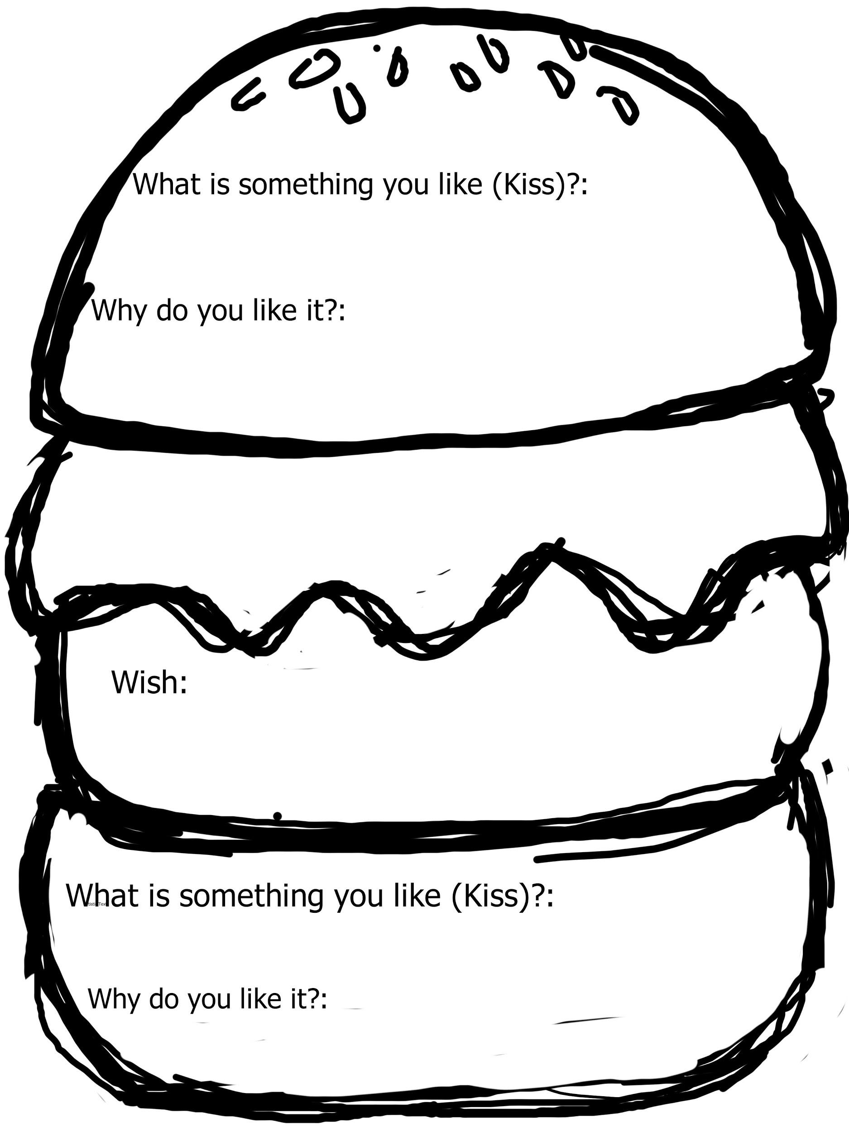  😊 😐 😟  Used work time effectively and efficiently  There are five pieces, they all have foam and they are put together to form the animal they were assigned  All of their pieces are colored using printmaking or paint and pastel

Self-Reflection:
After the lesson is concluded write a brief reflection of what went well, what surprised you, and what you would do differently. Specifically address: (1) To what extent were lesson objectives achieved? (Utilize assessment data to justify your level of achievement.) (2) What changes, omissions, or additions to the lesson would you make if you were to teach again? (3)What do you envision for the next lesson? (Continued practice, reteach content, etc.)
Overall the lesson went pretty well most students were able to meet the objects and learning targets. However this lesson may have been to hard for second graders for those who had trouble understanding directions it was very hard for them. This project was a lot of steps and I think too complicated for this age group. There were some problems understanding what the pieces were for and what to do with them. For me as the teacher it was very hard to keep track of all of their pieces and a lot of management. I thought however the students enjoyed the project especially the printing they also did a wonderful job observing what they say on their animal and trying to mimic it. I also really think the students enjoyed drawing and working with foam. The students all completed the project and each one seemed to reflect the students individual style. They were able to talk about their projects and others using what they had learned. I also feel that I really had trouble differentiating instruction for this project especially for the drawing portion and explaining what to do with the smaller pieces.

Appendix: Include all handouts, prompts, written materials, rubrics, etc. that will be given to students.

Animal examples for students

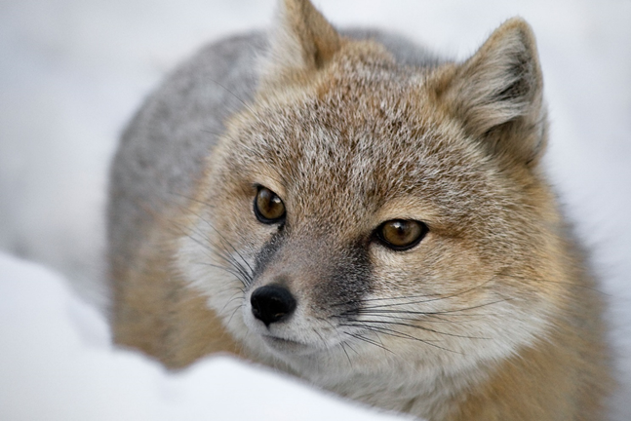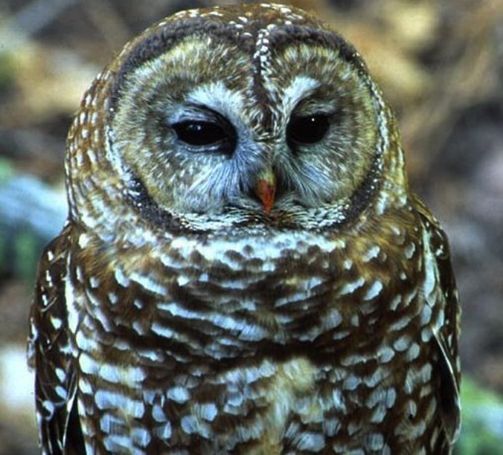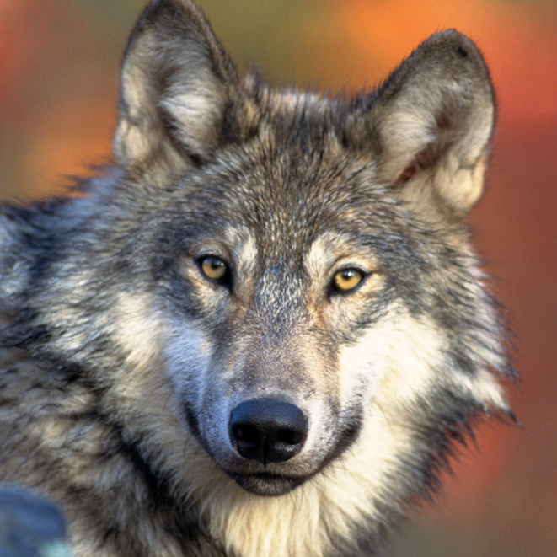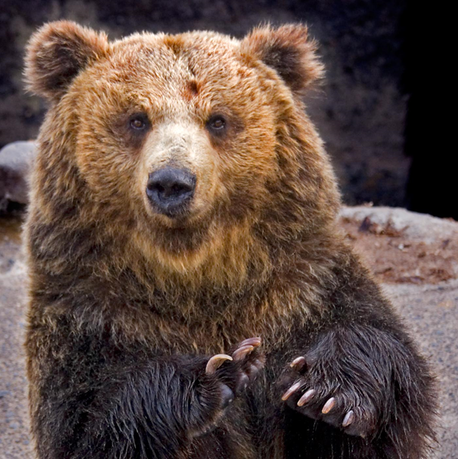

Animal: Name: Class:

Where do they live?

Why are they endangered?

What do they look like?

What is a fun fact about them?

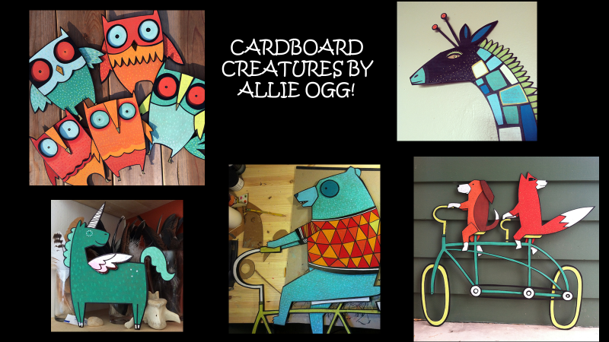

8/9/15 Fahey

