Lesson Plan Title: Gelli Prints Length: 6 days

Note: Before you plan and write art experiences; pre-assess your students based on the proposed concepts, enduring understandings, and objectives of the unit/lesson(s). You may also gather this information from (previous) teachers, by reviewing already completed art work, consulting curriculum materials, etc., to get a better understanding of what content students already know and what they will need to know to be successful.

Pre-Assessment:
This will need to be done prior to teaching your lesson. Outline the method you will use to determine the skill/knowledge level of your students based on the concepts/enduring understandings/objectives of the lesson. (Hint: turn these into questions.) Be specific in describing what you would recognize as proficient skill/knowledge.
Questions out loud:
What do you think printmaking is?
What is a monoprint?
What is a collage?
What is mixed media?
What are different ways you can make monoprints?

Performance:
What will students accomplish as a result of this lesson? This can be presented to students in the form of a story. In this narrative the students take on a role and create a learning product about a specific topic for a certain audience. (RAFT – Role / Audience / Format / Topic)P

- Role: Artist
- Audience: classmates and teachers
- Format: monoprinting
- Topic: make a landscape using various prints and materials

Concepts:
List the big ideas students will be introduced to in the lesson. These ideas are universal, timeless and transferrable. Examples of concepts used in art might include: Composition, Patterns, Technique, Rhythm, Paradox, Influence, Style, Force, Culture, Space/Time/Energy, Line, Law/Rules, Value, Expressions, Emotions, Tradition, Symbol, Movement, Shape, Improvisation, and Observation Look for concepts in the standards, content specific curriculum, etc.
Composition
Repetition/Reproduction
Style
Shape
Improvisions
Observations
Expressions
Movement
Technique
Collaboration
Pattern

Enduring Understanding (s):
Enduring Understandings show a relationship between two or more concepts; connected with an active verb. The best enduring understandings not only link two or more concepts; but demonstrate why this relationship is important. Like concepts, they are timeless, transferrable and universal.
Artists can plan and use stylistic choices, various processes and techniques to make a complete and unified composition
Artists can use background knowledge to create works of art
Artists can make creative decisions based on observations and understandings
Artists understand the importance of process, following steps and recording results

Standards: (All lessons should address all standards.)
1. Observe and Learn to Comprehend
2. Envision and Critique to Reflect
3. Invent and Discover to Create
4. Relate and Connect to Transfer

Objectives/Outcomes/Learning Targets:
Objectives describe a learning experience with a condition → behavior (measurable) → criterion. Aligned to: Bloom’s – Standards – GLEs - Art learning and, when appropriate, Numeracy, Literacy and Technology. Should be written as: Objective. (Bloom’s: _____ - Standard: _____ - GLE: _____ -Art learning: _____ -Numeracy, Literacy, and/or Technology)
1.Given Demonstration and observation SWBAT understand how to create and produce 4 to 6 monoprints and gelli prints using basic printmaking techniques and make notes on their process, progress and results
Bloom’s: understand, Standard: Comprehend, GLE 1: The characteristics and expressive features of art and design are used in analyzing and synthesizing the meaning in works of art, Art Learning: expressive features and inherent characteristics, Literacy: asking, answering questions, listening, collaborating, discussing, recording, Numeracy: using size, proportion, pattern, time, space, problem solving through process
PGC’s
- Analyze, interpret, and make meaning of art and design critically using oral and written discourse
- Explain, demonstrate, and interpret a range of purposes of art and design, recognizing that the making and study of art and design can be approached from a variety of viewpoints, intelligences, and perspectives

2. Given instruction, demonstration and artist examples SWBAT make gelli prints that have at least two or more different layers and a different color for each layer and minimal white space in each print that demonstrate creative problem solving and show individual intent.
Bloom’s: remember, Standard: Create, GLE 2:, Restructure and apply the technical skills and processes required to achieve desired results in producing works of art Art Learning: expressive features and inherent characteristics, Literacy:asking, answering questions, listening, collaborating, discussing, recording Numeracy: using size, proportion, pattern, time, problem solving through process
PGC’s
- Develop and build appropriate mastery in art-making skills using traditional and new technologies and an understanding of the characteristics and expressive features of art and design
- Create works of art that articulate more sophisticated ideas, feelings, emotions, and points of view about art and design through an expanded use of media and technologies
3. Using background knowledge SWBAT to create a mixed media landscape composition of their choice that uses foreground, background and a middle ground, at least four prints, collage techniques and one other media on a 8 by 8 piece of tagboard that express individual intent and decision making.
Bloom’s: apply, Standard: Reflect, GLE 2: Concepts, issues, and themes in the visual arts can be used to communicate ideas in various other disciplines, Art Learning: Literacy:asking, answering questions, listening, collaborating, discussing, recording, critical thinking Numeracy:using size, proportion, pattern, time, problem solving through process
PCG’s
- Recognize, articulate, and implement critical thinking in the visual arts by synthesizing, evaluating, and analyzing visual information
- Use specific criteria to discuss and evaluate works of art

4. Using prior knowledge and intent SWBAT create a final design that demonstrates Overall good Craftsmanship, understanding of process and personal connection and creation of the work
Bloom’s: Create, Standard: Create, GLE 1: Achieve the ability to plan, anticipate outcomes, and demonstrate craftsmanship in creating a work of art, Art Learning: tools and techniques, Literacy:asking, answering questions, listening, collaborating, discussing, recording, vocabulary, critical thinking, Numeracy: using size, proportion, pattern, time, problem solving through process
PGC’s
- Create works of art that articulate more sophisticated ideas, feelings, emotions, and points of view about art and design through an expanded use of media and technologies
- Recognize, interpret, and validate that the creative process builds on the development of ideas through a process of inquiry, discovery, and research
5. Using understandings of process, material and media, SWBAT reflect on their final designs using vocabulary, artists and culture, personal connections and creative decision making.
Bloom’s: understand, Standard: Transfer, GLE 2: The visual arts community messages its cultural traditions and events, Art Learning: Art history and culture, Literacy:asking, answering questions, listening, collaborating, discussing, recording, critical thinking, Numeracy: using size, proportion, pattern, time, problem solving through process
PGC’s
- Identify, compare, and interpret works of art derived from historical and cultural settings, time periods, and cultural contexts
- Identify, compare and justify that the visual arts are a way to acknowledge, exhibit and learn about the diversity of peoples, cultures and ideas

Differentiation:
Explain specifically how you have addressed the needs of exceptional students at both end of the skill and cognitive scale. Describe the strategies you will use for students who are already proficient and need growth beyond what you have planned for the rest of the class, as well as modifications for students with physical and/or cognitive challenges. Students must still meet the objectives.

Differentiation:  (Multiple means for students to access content and multiple modes for student to express understanding.) | Access (Resources and/or Process) | Expression (Products and/or Performance)
 | Google Classroom  teachers  students  computers  youtube  handouts  personal notes and observations  For students with fine motor skills challenges, the process could focus on getting the student familiar with making marks, practice note taking skills by making observations and recording them. Students have a choice on the composition they would like to create, the colors, layout and marks and overall style and intent in the piece. The process will be demoed and reviewed for absent students that need to see the process again. Questions and working with classmates is also encouraged. | For Ideation students will be asked to create abstract compositions and make notes on observations, successes, failures, happy accidents and steps taken to achieve these results. For the final product students will create a collage of at least 5 of their prints that represent a landscape of their choosing. The project must express individual intent, show understanding of landscape composition, color and texture and mark making.
Extensions for depth and complexity: | Access (Resources and/or Process) | Expression (Products and/or Performance)
 | Recording helps the student begin to develop an artist statement and new ideas by referring back to how they achieved something through the process. Students also begin to observe art in various ways and develop understanding and intent for works of art. Students are able to use prior knowledge of mediums and processes and combine them to create a cohesive composition. Students will practice creating abstract and representational works of art separately and then combine them | Students are able to choose colors and compositions that include mark making that can be representational or abstract allowing for free expression and exploration. The final design will reflect the artists and their process, intent and personal connections to the work based on the marks, colors, textures, media and overall design.

Literacy:
List terms (vocabulary) specific to the topic that students will be introduced to in the lesson and describe how literacy is integrated into the lesson.
resist
relief
ink
brayer
composition
style
repetition
pattern
color
layering
monoprint
mixed media
collage
printmaking
gelli print
foreground
background
horizon line
middle ground
landscape
color scheme
process

Answering and asking questions about the material and process, planning out stamp designs which may include letters and words (and considering that whatever they write or draw on their stamp will be flipped), discussing with peers and instructors various ideas and processes; listening to instructions and completing them successfully.
Taking notes on processes and recording what they observe, steps, failures, intentions, successes, reflections.

Materials:
Must be grade level appropriate. List everything you will need for this lesson, including art supplies and tools. (These are the materials students will use.) List all materials in a bulleted format.
- pre-cut tag board 8 by 8
- pre-cut watercolor paper 6 by 6 and 4 by 4
- crayons
- pastels
- colored pencils
- watercolors
- scissors
- stick glue/rubber cement
- sketchbooks
- pre-cut paper for jelli prints 7 by 7
- gelli plates
- mylar/ plexiglass
- water bins
- towels
- powerpoints
- handouts
- Google classroom
- washable markers
- teacher and student examples

Resources:

List all visual aids and reference material (books, slides, posters, etc. Be specific; include title, artist, etc. Make reference to where the material can be found. (These are the resources used by the teacher to support/develop the lesson.) List all resources in a bulleted format.
- Personal prints and students examples
- Prints by Degas, Picasso, Seghers
- Youtube videos
- Google classroom with powerpoints, handouts and videos
- Materials can be found in the classroom in the supply cabinet and storage room

Preparation:
What do you need to prepare for this experience? List steps of preparation in a bulleted format.
- Create powerpoints and handouts
- Create teacher examples
- Create printing station with all materials needed for the day.
- Create clean up sheets
- Have materials set out before class
- Water in bins
- Towels out
- Markers/paint/ink and mylar/gelli prints easily accessible

Safety:

Be specific about the safety procedures that need to be addressed with students. List all safety issue in a bulleted format.
When using scissors walk, do not run, do not cut anything other than your paper, cut away from yourself and others.
Do not eat or sniff glue, ink, markers or any other media used.

Action to motivate/Inquiry Questions:
Describe how you will begin the lesson to stimulate student’s interest. How will you pique their curiosity and make them interested and excited about the lesson? What inquiry questions will you pose? Be specific about what you will say and do to motivate students and get them thinking and ready to participate. Be aware of the varying range of learning styles/intelligences of your students. Some ideas might include: telling a story, posing a series of questions, role-playing, etc.
What is printmaking?
What are some uses for printmaking?
What is a monoprint?
How can we use abstract compositions, marks and textures to tell express intent or meaning behind the work?
How is printmaking different than other mediums?
Why is it important for us to know process?
Why should we take notes on our artwork? Especially while creating using a process?
How can I make prints and techniques to express my intent through landscape?
What is mixed media?
How can I use it to create a landscape using collage?
What is layering? How does it change colors, textures, patterns overall compositions?
Why is this an important skill?
How can I use monoprinting or printmaking in other content areas?

Ideation/Inquiry:
Ideation is the creative process of generating, developing, and communicating new ideas, where an idea is understood as a basic element of thought that can be visual, concrete or abstract. List and describe inquiry questions and processes you will engage students in to help them develop ideas and plans for their artwork.
Creating abstract monoprints using mylar and magic marker writing down, and recording observations and results in sketchbooks.
Next class create more representational compositions using one print from a partner and give the abstract design as a background and creating a foreground for it using what they know about. These results will also be recorded for this one print
Students then use layering and basic knowledge from notes and demo to create jelli prints using abstract and representational imagery.
What worked and what didn’t?
If I could do this again I would?
What happened when I…..?
What steps did I take?
What did I do?
Why did I do it this way?
What happens if I…?
What do I like about this? Why?
If I could do it again I would do differently?

Instruction:
Give a detailed account (in bulleted form) of what you will teach. Be sure to include approximate time for each activity and instructional methodology: skills, lecture, inquiry, etc. Include motivation and ideation/inquiry where appropriate; including what student will understand as a result of the art experience

Day 1 | 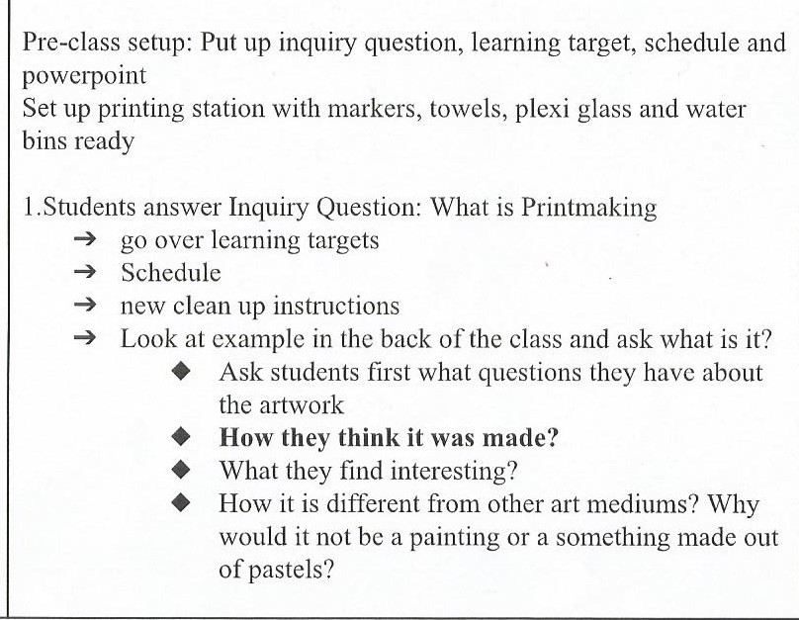  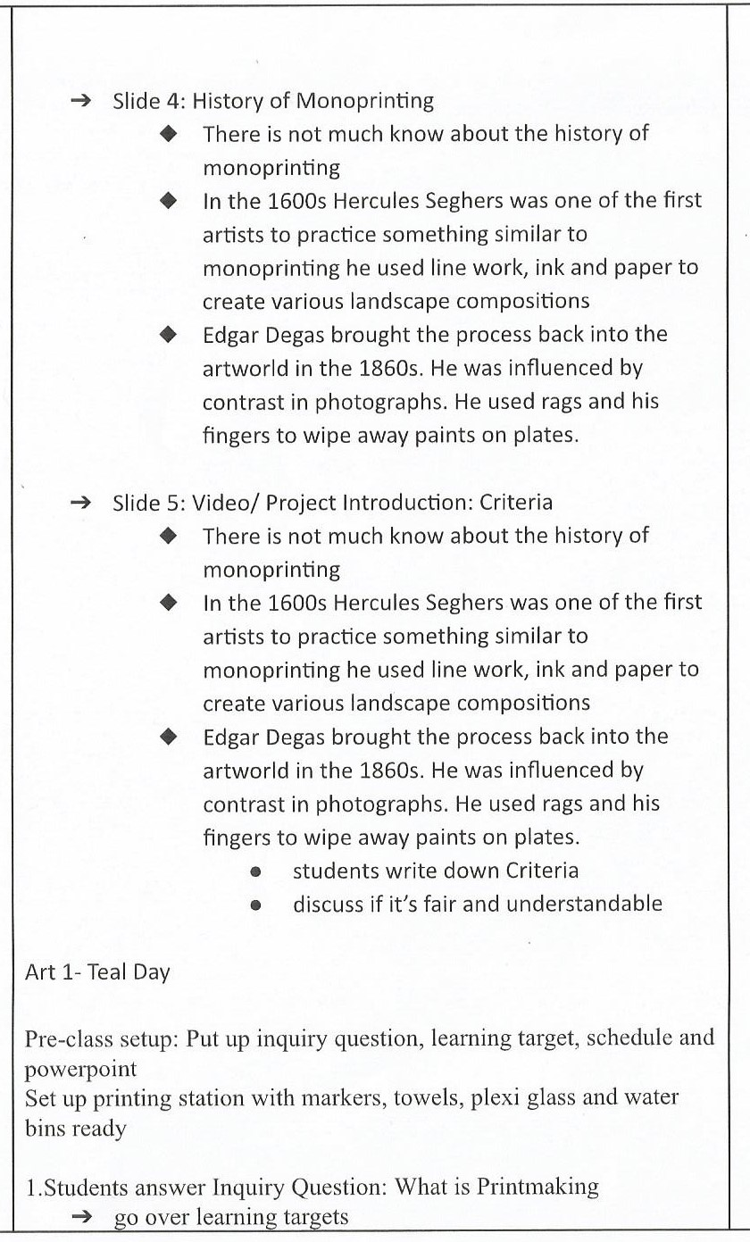  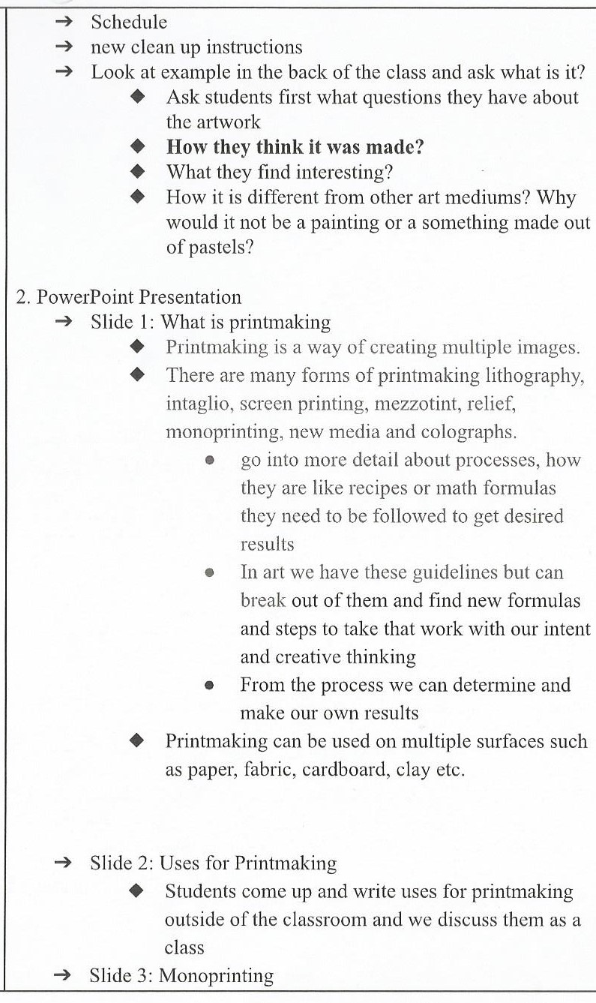  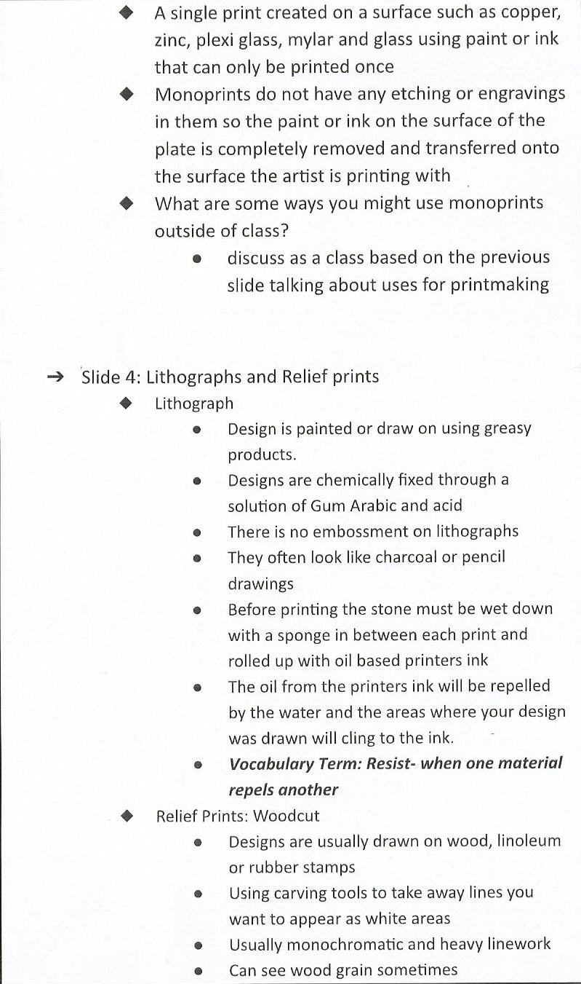  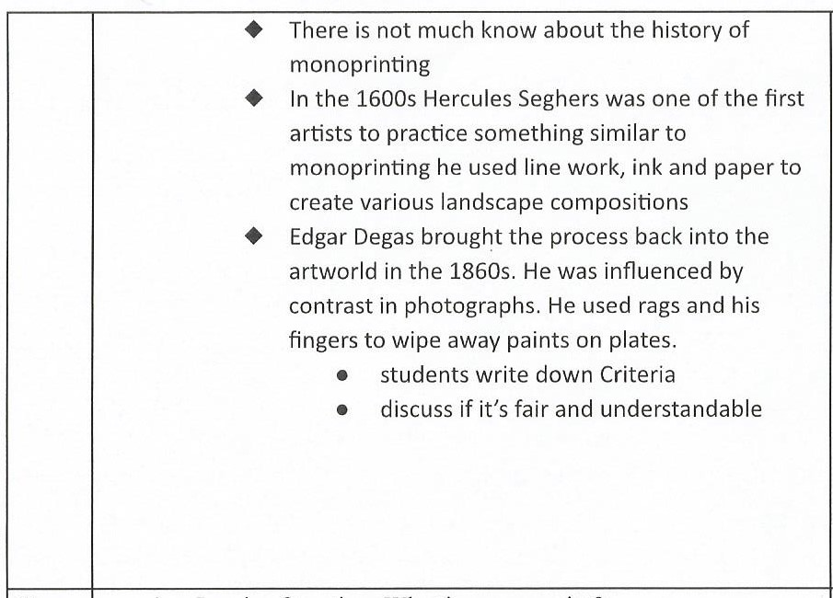 | review, remember, discuss, compare, contrast, brainstorm ideation, literacy  listening, synthesizing information, ideation, compare, contrast, make connection, explore, collaboration, critical thinking, literacy, practicing process and observations  making connections, observing and synthesizing art, comparing and contrasting, ideation | 10 min  12:31-12:41  10 min  12:41-12:51  39 min  12:51- 1:30  20 min  1:30-1:50
Day 2 | Inquiry Question: What is a monoprint?  - Learning Targets: I can write observations down about my artwork  - I can make monoprints using markers and plexi glass  - I can understand how to make monoprints using Gelli prints  2.Review last class  - what is printmaking  - go over vocabulary sheets  - finish powerpoint- showing processes  - have students write down criteria for the project  - show examples  - set up sketchbook  3. Demo monoprinting activity  - Students gather around with sketchbooks and write down steps as I go through them  - For the first step I will pass a piece of mylar/ plexi around and students will each make a few marks in one area that will then be my print  - After printed we will go around and make notes on the marks made on that print as a class  - Switch prints with a partner and try printing this will be your fourth print  3. Work time  - Students will create 3 to 5 monoprints and record results in sketchbooks between prints  - I will put up the powerpoint slide with instructions for the process  - I will walk around and observe and help students  4. Clean up  5. Artist activity  - students go onto google classroom and look on the artist list provided  - choose one artist they like and answer questions about the artist  - turn into google classroom  - exit ticket?  end class  Teal Day Art 1  - Inquiry Question: What is a monoprint?  - Learning Targets: I can write observations down about my artwork  - I can make monoprints using markers and plexi glass  - I can understand how to make monoprints using Gelli prints  2.Review last class  - what is printmaking  - show examples  - set up sketchbook  3. Demo monoprinting activity  - Students gather around with sketchbooks and write down steps as I go through them  - For the first step I will pass a piece of mylar/ plexi around and students will each make a few marks in one area that will then be my print  - After printed we will go around and make notes on the marks made on that print as a class  - Switch prints with a partner and try printing this will be your fourth print  3. Work time  - Students will create 3 to 5 monoprints and record results in sketchbooks between prints  - I will put up the powerpoint slide with instructions for the process  - I will walk around and observe and help students  - will stop student after about 20 minutes and have them trade with a partner  4. Clean up  - put up and go over the clean up and put up slide  5. Artist activity  - students go onto google classroom and look on the artist list provided  - choose one artist they like and answer questions about the artist  - turn into google classroom  - exit ticket? | review, remember, discuss, compare, contrast, brainstorm ideation, literacy  listening, synthesizing information, ideation, compare, contrast, make connection, explore, collaboration, critical thinking, literacy, practicing process and observations  making connections, observing and synthesizing art, comparing and contrasting, ideation  review, remember, discuss, compare, contrast, brainstorm ideation, literacy  listening, synthesizing information, ideation, compare, contrast, make connection, explore, collaboration, critical thinking, literacy, practicing process and observations  making connections, observing and synthesizing art, comparing and contrasting, ideation | 5 min  12:31-12:36  10 min  12:36-12:46  10 min  12:46-12:56  35 min  12:56- 1:30  20 min  1:30-1:50  5 min  12:31-12:36  10 min  12:36-12:46  10 min  12:46-12:56  35 min  12:56- 1:30  20 min  1:30-1:50
Day 3 | Art 1- Purple  1.Inquiry Question: When you walk into room find your monoprints from last class, glue them in your sketchbooks and about 2 to 3 notes about at least 4 prints. Use your question sheet as a guide!  Learning Targets:  I can Reflect on my monoprints  I can make 4-6 Gelli Prints  I can use different colors, textures and layers on my gelli prints  2. pass back monoprints  - glue them in sketchbooks  - write down some observations  3. Demo Gelli Printing  - students will gather around the table  - how do you think this is going to work?  - What makes this a monoprint  - How is this different than working with the magic marker monoprints  - What type of effects textures marks do you notice that you can get using prints that you can not with other media?  - show inking techniques-- the ways colors mix how to apply pull one layer with texture---- pull a ghost print  - make another layer with a different color and add stamps or new textures show how to make foam stamps  - pressing firmly into paper plate with pen or pencil  - cut out shape  - ink plate press stamps into plate with paper on top  - remove paper and stamps  - put printing paper on top of Gelli plate  - Go over clean up instructions  - demo how to clean off gelli plate  4. Work time  - I will walk around and help students and observe  5. Clean up  - number students off for cleaning duties  - pass out checklists  - students must fill them out, have me check their table hand them in as their exit ticket  Art 1- Teal Day  1.Inquiry Question: When you walk into room find your monoprints from last class, glue them in your sketchbooks and about 2 to 3 notes about at least 4 prints. Use your question sheet as a guide!  Learning Targets:  I can Reflect on my monoprints  I can make 4-6 Gelli Prints  I can use different colors, textures and layers on my gelli prints  2. pass back monoprints  - glue them in sketchbooks  - write down some observations  3. Demo Gelli Printing  - students will gather around the table  - how do you think this is going to work?  - What makes this a monoprint  - How is this different than working with the magic marker monoprints  - What type of effects textures marks do you notice that you can get using prints that you can not with other media?  - show inking techniques-- the ways colors mix how to apply pull one layer with texture---- pull a ghost print  - make another layer with a different color and add stamps or new textures show how to make foam stamps  - pressing firmly into paper plate with pen or pencil  - cut out shape  - ink plate press stamps into plate with paper on top  - remove paper and stamps  - put printing paper on top of Gelli plate  - Go over clean up instructions  - demo how to clean off gelli plate  - tell students when they are done with prints to put their name, class period and put prints on the drying rack  4. Work time  - I will walk around and help students and observe  5. Clean up  - students wash of brayers and plates  - they bring them up to me and I have them sign the check out in sheet to show that they have cleaned and returned the brayers and plates  - Students who have finished cleaning off their plates and brayers will be assigned other jobs such as cleaning of the tables, sinks and throwing away scraps of paper | review, remember, discuss, compare, contrast, brainstorm ideation, literacy  listening, synthesizing information, ideation, compare, contrast, make connection, explore, collaboration, critical thinking, literacy, practicing process and observations  making connections, observing and synthesizing art, comparing and contrasting, ideation, answering and asking questions, collaborating  review, remember, discuss, compare, contrast, brainstorm ideation, literacy  listening, synthesizing information, ideation, compare, contrast, make connection, explore, collaboration, critical thinking, literacy, practicing process and observations  making connections, observing and synthesizing art, comparing and contrasting, ideation, asking and answering questions, collaborating  practicing good studio habits, collaborating, following directions | 15 min  12:31-12:46  15 min  12:46-1:01  34 min  1:01-1:35  15 min  1:35-1:50  15 min  12:31-12:46  15 min  12:46-1:01  34 min  1:01-1:35  15 min  1:35-1:50
Day 4 | Art 1- Purple Day  Inquiry Question: What are mixed media and collage in art?  Learning Targets:  - I can understand the different parts of landscape, mixed media and collage  - I can use my understanding to create a mixed media collage of a landscape using my prints  2. Present powerpoint on landscapes, collage and mixed media  - Slide 1: What are the important parts of a landscape?  - Image of a landscape  - call on students and ask them what the important parts are and where and what they are  - Slide 2: Parts of a landscape labelled  - image of a landscape with labels  - talk about criteria  - Students will then draw out a landscape they might like to make for their collage and label it based on the image on the powerpoint they can research or look at images of landscapes  - Slide 3: Collage examples  - ask students what a collage is and discuss the collage images on the slide  - Slide 4: Mixed Media Example  - ask students what is mixed media  - talk about the definition  - ask what types of mediums they see in the image  - discuss  - Slide 5: Project Examples  - images of previous projects made by students using mixed media, collage and print techniques of landscapes  - discuss  - answer questions  - Talk about the printing stations and that they will have a little bit of time to print  - only about 15-20 minutes for this mainly for kids who do not have more than one layer or were absent  - show where tag board is  - talk about materials they can use for mixed media  - demo and talk about filling in white spaces in prints with different media  3. Work time  - students work on prints and collages  - walk around and provide assistance if needed and monitor progress and class  4. Clean up  - printmaking materials cleaned up  - collage materials out away  - sketchbooks put away  Art 1-Teal Day  Inquiry Question: What are mixed media and collage in art?  Learning Targets:  - I can understand the different parts of landscape, mixed media and collage  - I can use my understanding to create a mixed media collage of a landscape using my prints  2. Present powerpoint on landscapes, collage and mixed media  - Slide 1: What are the important parts of a landscape?  - Image of a landscape  - call on students and ask them what the important parts are and where and what they are  - Slide 2: Parts of a landscape labelled  - image of a landscape with labels  - talk about criteria  - Students will then draw out a landscape they might like to make for their collage and label it based on the image on the powerpoint they can research or look at images of landscapes  - Slide 3: Collage examples  - ask students what a collage is and discuss the collage images on the slide  - Slide 4: Mixed Media Example  - ask students what is mixed media  - talk about the definition  - ask what types of mediums they see in the image  - discuss  - Slide 5: Project Examples  - images of previous projects made by students using mixed media, collage and print techniques of landscapes  - discuss  - answer questions  - Talk about the printing stations and that they will have a little bit of time to print  - only about 15-20 minutes for this mainly for kids who do not have more than one layer or were absent  - show where tag board is  - talk about materials they can use for mixed media  - demo and talk about filling in white spaces in prints with different media  3. Work time  - students work on prints and collages  - walk around and provide assistance if needed and monitor progress and class  4. Clean up  - printmaking materials cleaned up  - collage materials out away  - sketchbooks put away  Art 1- Purple Day  1.demo and talk about materials-- students gather around the table  - watercolor gradient for background  - show filling in areas with other materials on prints  - talk about using paper towels for texture on watercolor  - layering  - students can use markers colored pencils, crayons, pastels, watercolor, monoprints, gelli prints, felt tip marker  - use prior knowledge about color and pattern  - take risks, experiment  - clean up  2.Inquiry Question: What types of other materials or mediums do you want to use for your landscape collage?  Learning targets:  - I can create a landscape with a foreground, middleground and background using mixed media.  - I can create a collage landscape by using at least 4 of my prints  - Before students can begin working they have to show me their inquiry question in their sketchbooks  3. Work Day  - sponge activity make another print using day or night, seasons whichever one you did not use for your college  - check in and help students who need help  - answer and ask questions  - motivate and monitor  4. Clean up  - wash out water color trays  - wash brushes  - put away colored pencils and pastels  - wipe down tables  Art 1- Teal Day  1.demo and talk about materials-- students gather around the table  - watercolor gradient for background  - show filling in areas with other materials on prints  - talk about using paper towels for texture on watercolor  - layering  - students can use markers colored pencils, crayons, pastels, watercolor, monoprints, gelli prints, felt tip marker  - use prior knowledge about color and pattern  - take risks, experiment  - clean up  2..Inquiry Question: What types of other materials or mediums do you want to use for your landscape collage?  Learning targets:  - I can create a landscape with a foreground, middleground and background using mixed media.  - I can create a collage landscape by using at least 4 of my prints  - Before students can begin working they have to show me their inquiry question in their sketchbooks  3. Work Day  - sponge activity make another print using day or night, seasons whichever one you did not use for your college  - check in and help students who need help  - answer and ask questions  - motivate and monitor  4. Clean up  - wash out water color trays  - wash brushes  - put away colored pencils and pastels  - wipe down tables | review, remember, discuss, compare, contrast, brainstorm ideation, literacy  listening, synthesizing information, ideation, compare, contrast, make connection, explore, collaboration, critical thinking, literacy, practicing process and observations  connections, observing and synthesizing art, comparing and contrasting, ideation, asking and answering questions, collaborating  practicing good studio habits, collaborating, following directions  review, remember, discuss, compare, contrast, brainstorm ideation, literacy  listening, synthesizing information, ideation, compare, contrast, make connection, explore, collaboration, critical thinking, literacy, practicing process and observations  making connections, observing and synthesizing art, comparing and contrasting, ideation, asking and answering questions, collaborating  practicing good studio habits, collaborating, following directions  review, remember, discuss, compare, contrast, brainstorm ideation, literacy  listening, synthesizing information, ideation, compare, contrast, make connection, explore, collaboration, critical thinking, literacy, practicing process and observations  making connections, observing and synthesizing art, comparing and contrasting, ideation, asking and answering questions, collaborating  practicing good studio habits, collaborating, following directions  review, remember, discuss, compare, contrast, brainstorm ideation, literacy  listening, synthesizing information, ideation, compare, contrast, make connection, explore, collaboration, critical thinking, literacy, practicing process and observations  making connections, observing and synthesizing art, comparing and contrasting, ideation, asking and answering questions, collaborating  practicing good studio habits, collaborating, following directions | 5 min  12:31pm-12:41pm  5 min  12:41-12:46  15 min  12:46-1:01  7 min  1:01-1:08  25 min  1:08-1:35  15 min  1:35-1:50  5 min  12:31-12:41pm  5 min  12:41-12:46  15 min  12:46-1:01  7 min  1:01-1:08  25 min  1:08-1:35  15 min  1:35-1:50  10 min  12:31-12:41  10 min  12:41-12:51  49 min  12:51-1:40  10 min  1:40-1:50  10 min  12:31-12:41  10 min  12:41-12:51  49 min  12:51-1:40  10 min  1:40-1:50
Day 5 | Art 1- Purple Day  1.Inquiry Question: What extra details am I going to add to my mixed media landscape?  Learning Targets:  - I can add details to my mixed media landscape  - I can finish my mixed media landscape  2. Sketchbook checks  - write on the board what students need to have in their sketchbooks  - 14 inquiry questions  - mandala worksheets and example  - vocabulary terms  - printmaking notes and prints  - ideation sketches  - artifact sheet (1 quote about them as an artist)  - hall pass  - students self assess their work habits and sketchbooks  - check off the list on the board and give themselves a score out of 7  - students who have not used their passess turn them in for a treat  - call students up table by table and check their sketchbooks and enter grades  3. Demo details for landscapes  - students gather around the table  - show them acrylic paint (gold, silver, white)  - show them how to make dots using q-tips and the back of the brushes  - show using felt tip marker to outline or draw with  - talk about clean up  - the acrylic paint stays on the opposite side of the sink than the water colors  - the acrylic and watercolor brushes are separated and need to be put away in the correct place  4. Work time  - I walk around and help, answer and ask questions  - monitor room  - call students up for sketchbook checks  - When finished students work on a new collage with a partner or by themselves  - can also do an artist activity on google classroom where they research an artist and answer questions  5. Clean up  - wash out water color trays  - clean of brushes  - dump out water used for painting  - put extra prints in the communal print bin  - throw away scraps  - wipe down tables and sinks  - put prints in the turn in box or on the drying rack (name and period on the back)  Art 1-Teal Day  1.Inquiry Question: What extra details am I going to add to my mixed media landscape?  Learning Targets:  - I can add details to my mixed media landscape  - I can finish my mixed media landscape  2. Sketchbook checks  - write on the board what students need to have in their sketchbooks  - 14 inquiry questions  - mandala worksheets and example  - vocabulary terms  - printmaking notes and prints  - ideation sketches  - artifact sheet (1 quote about them as an artist)  - hall pass  - students self assess their work habits and sketchbooks  - check off the list on the board and give themselves a score out of 7  - students who have not used their passess turn them in for a treat  - call students up table by table and check their sketchbooks and enter grades  3. Demo details for landscapes  - students gather around the table  - show them acrylic paint (gold, silver, white)  - show them how to make dots using q-tips and the back of the brushes  - show using felt tip marker to outline or draw with  - talk about clean up  - the acrylic paint stays on the opposite side of the sink than the water colors  - the acrylic and watercolor brushes are separated and need to be put away in the correct place  4. Work time  - I walk around and help, answer and ask questions  - monitor room  - call students up for sketchbook checks  - When finished students work on a new collage with a partner or by themselves  - can also do an artist activity on google classroom where they research an artist and answer questions  5. Clean up  - wash out water color trays  - clean of brushes  - dump out water used for painting  - put extra prints in the communal print bin  - throw away scraps  - wipe down tables and sinks  - put prints in the turn in box or on the drying rack (name and period on the back) | review, remember, discuss, compare, contrast, brainstorm ideation, literacy  listening, synthesizing information, ideation, compare, contrast, make connection, explore, collaboration, critical thinking, literacy, practicing process and observations  making connections, observing and synthesizing art, comparing and contrasting, ideation, asking and answering questions, collaborating  practicing good studio habits, collaborating, following directions  review, remember, discuss, compare, contrast, brainstorm ideation, literacy  listening, synthesizing information, ideation, compare, contrast, make connection, explore, collaboration, critical thinking, literacy, practicing process and observations  making connections, observing and synthesizing art, comparing and contrasting, ideation, asking and answering questions, collaborating  practicing good studio habits, collaborating, following directions | 5 min  12:31-12:36  introduced for 10 min then continues throughout class by table group  12:36-12:46  7 min  12:46-12:53  47 min  12:53-1:40  1:40-1:50  10 min  5 min  12:31-12:36  introduced for 10 min then continues throughout class by table group  12:36-12:46  7 min  12:46-12:53  47 min  12:53-1:40  1:40-1:50  10 min
Day 6 | Art 1- Purple Day  Inquiry Question: what was your favorite part of this project?  Learning targets:  - I can finish my landscape collage  - I can reflect on my landscape collage  - I can use drawing prompts to create my own works of art  1.Go over schedule  - Work time  - Go over PowerPoint and introduce artist statement and grading rubric  - Work time until the end of class. Assignments must be turned in at the end of class  - More work time  - Clean up  2.Work time to finish collage and work on drawing prompts  - Walk around and monitor classroom  - Answer and ask questions  - Help  3.PowerPoint presentation on artist statement  4. Work time to finish collage, work on drawing prompts and fill out rubric and artist statement  - Walk around and monitor classroom  - Answer and ask questions  - Help  - Push students on their artist statements  - students who are done work on artist statements and self grade on the rubric attached  - on the rubric students include name:, period:(P5) and assignment name (printmaking collage)  - The project is due at the end of class with rubric attached  5. Clean up  - Put glue sticks, scissors, pastels, watercolors away  - Wipe down tables  - Throw away newsprint for painting on  - Put away sketchbooks  - Turn in collages with artist statements to the P5 turn in box  Art 1: Teal Day  Inquiry Question: what was your favorite part of this project?  Learning targets:  - I can finish my landscape collage  - I can reflect on my landscape collage  - I can use drawing prompts to create my own works of art  1.Go over schedule  - Work time  - Go over PowerPoint and introduce artist statement and grading rubric  - Work time until the end of class. Assignments must be turned in at the end of class  - More work time  - Clean up  2.Work time to finish collage and work on drawing prompts  - Walk around and monitor classroom  - Answer and ask questions  - Help  - Push students on their artist statements  3.PowerPoint presentation on artist statement  4. Work time to finish collage, work on drawing prompts and fill out rubric and artist statement  - Walk around and monitor classroom  - Answer and ask questions  - Help  - Push students on their artist statements  - students who are done work on artist statements and self grade on the rubric attached  - on the rubric students include name:, period:(P5) and assignment name (printmaking collage)  - The project is due at the end of class with rubric attached  5. Clean up  - Put glue sticks, scissors, pastels, watercolors away  - Wipe down tables  - Throw away newsprint for painting on  - Put away sketchbooks  - Turn in collages with artist statements to the P5 turn in box | review, remember, discuss, compare, contrast, brainstorm ideation, literacy  listening, synthesizing information, ideation, compare, contrast, make connection, explore, collaboration, critical thinking, literacy, practicing process and observations  making connections, observing and synthesizing art, comparing and contrasting, ideation, asking and answering questions, collaborating  practicing good studio habits, collaborating, following directions  review, remember, discuss, compare, contrast, brainstorm ideation, literacy  listening, synthesizing information, ideation, compare, contrast, make connection, explore, collaboration, critical thinking, literacy, practicing process and observations  making connections, observing and synthesizing art, comparing and contrasting, ideation, asking and answering questions, collaborating  \  practicing good studio habits, collaborating, following directions | 5 min  12:31-12:36  2 min  12:36-12:39  21 min  12:39-1:00  10 min  1:00-1:10  30 min  1:10-1:40  10 min  1:40-1:50  5 min  12:31-12:36  2 min  12:36-12:39  21 min  12:39-1:00  10 min  1:00-1:10  30 min  1:10-1:40  10 min  1:40-1:50

Student reflective/inquiry activity:
Sample questions and activities (i.e. games, gallery walk, artist statement, interview) intended to promote deeper thinking, reflection and refined understandings precisely related to the grade level expectations. How will students reflect on their learning? A participatory activity that includes students in finding meaning, inquiring about materials and techniques and reflecting about their experience as it relates to objectives, standards and grade level expectations of the lesson.)
- Students will fill out and self grade themselves on their rubrics
- on the back of the rubric students will fill out their CERC Guide and will use their notes to help answer the questions to begin to develop artist statements and they will write four hashtags that describe their process and personal intent

Post-Assessment (teacher-centered/objectives as questions):  Have students achieved the objectives and grade level expectations specified in your lesson plan? | Post-Assessment Instrument:  How well have students achieved the objectives and grade level expectations specified in your lesson plan? Include your rubric, checklist, rating scale, etc.
- Did students make 4-6 gelli prints and monoprints?  - Did they take notes and use them to create other prints or better help with understanding of the process and exploring techniques  - Did students create a collage that demonstrates foreground, middleground, background, individual expression and intent, pattern, composition and mixed media?  - Did students use at least two or more layers on their gelli prints and experiment with colors, patterns, textures and relief techniques?  - How and why did you use this?  - What was your personal connection to this how does this reflect you? | 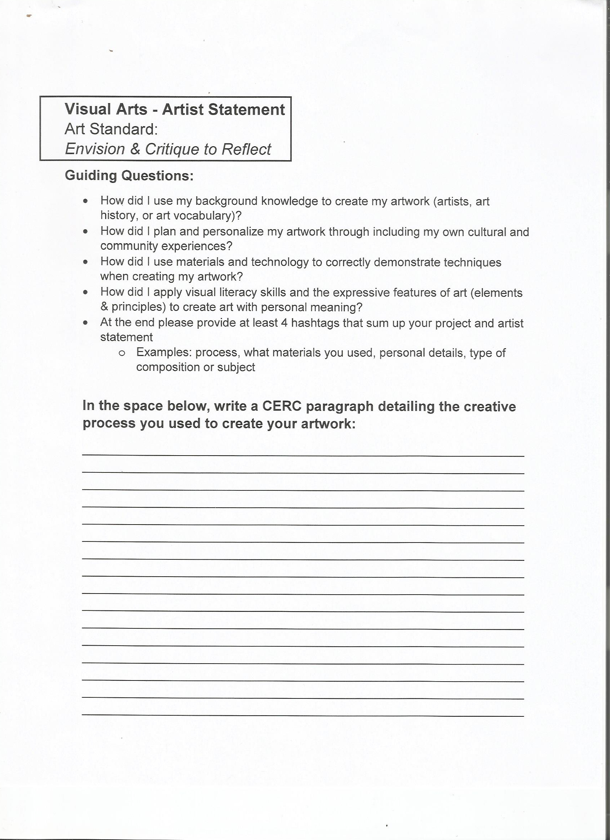  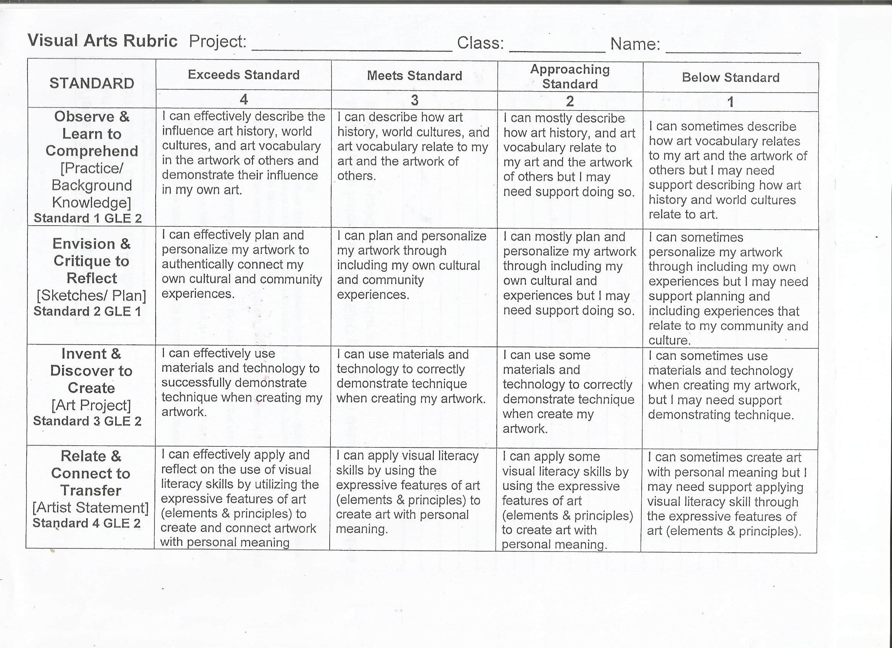

Self-Reflection:
After the lesson is concluded write a brief reflection of what went well, what surprised you, and what you would do differently. Specifically address: (1) To what extent were lesson objectives achieved? (Utilize assessment data to justify your level of achievement.) (2) What changes, omissions, or additions to the lesson would you make if you were to teach again? (3)What do you envision for the next lesson? (Continued practice, reteach content, etc.)
The lesson objectives were achieved by almost all of the students there were a few who did not have the three parts of the a landscape but still used collage techniques with prints. All of the student demonstrated an understanding of the process through both gelli prints and monoprints by adding several layers colors and experimenting with mark making and materials. Overall I think the lesson went well however I felt that the reflection activity and the artist statements were not as successful, students were unmotivated and were having trouble understanding how to write about their artwork. I need to try to help explain and give students more motivation for their statements, next time I may go over questions with students step by step about a piece of my artwork to model how to answer personal intent questions and have them help answer process and tools and techniques question. I would also change how I introduce the project by shortening presentations and maximizing artmaking time. I would use more visual and maybe some videos or modern techniques with gelli printing, monoprinting and maybe even collage.

Appendix: Include all handouts, prompts, written materials, rubrics, etc. that will be given to students.

Monoprinting Questions

- Use these questions as a guide when writing about results after printing

What worked and what didn’t?
If I could do this again I would?
What happened when I…..?
What steps did I take?
What did I do?
Why did I do it this way? What
result was I hoping for?
What happens if I…?
What do I like about this? Why?
If I could do it again I would do
differently?

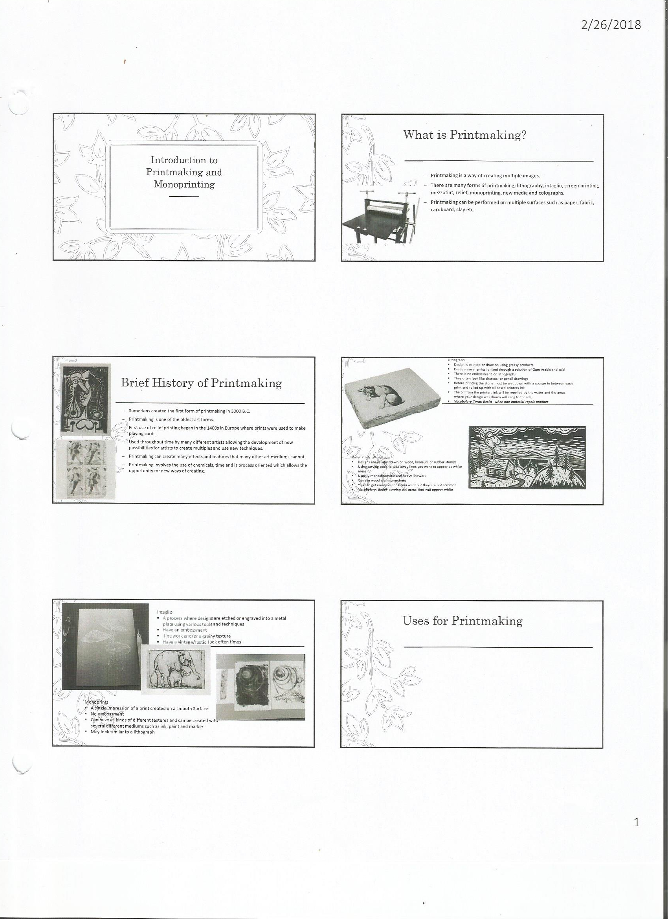

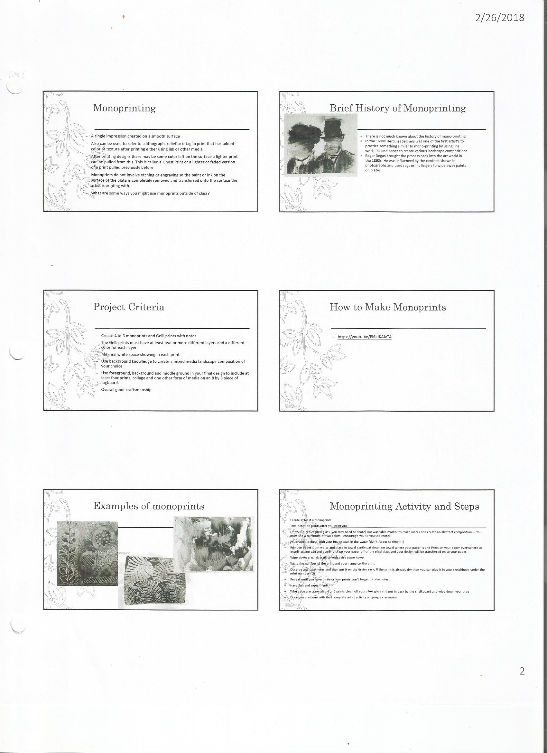
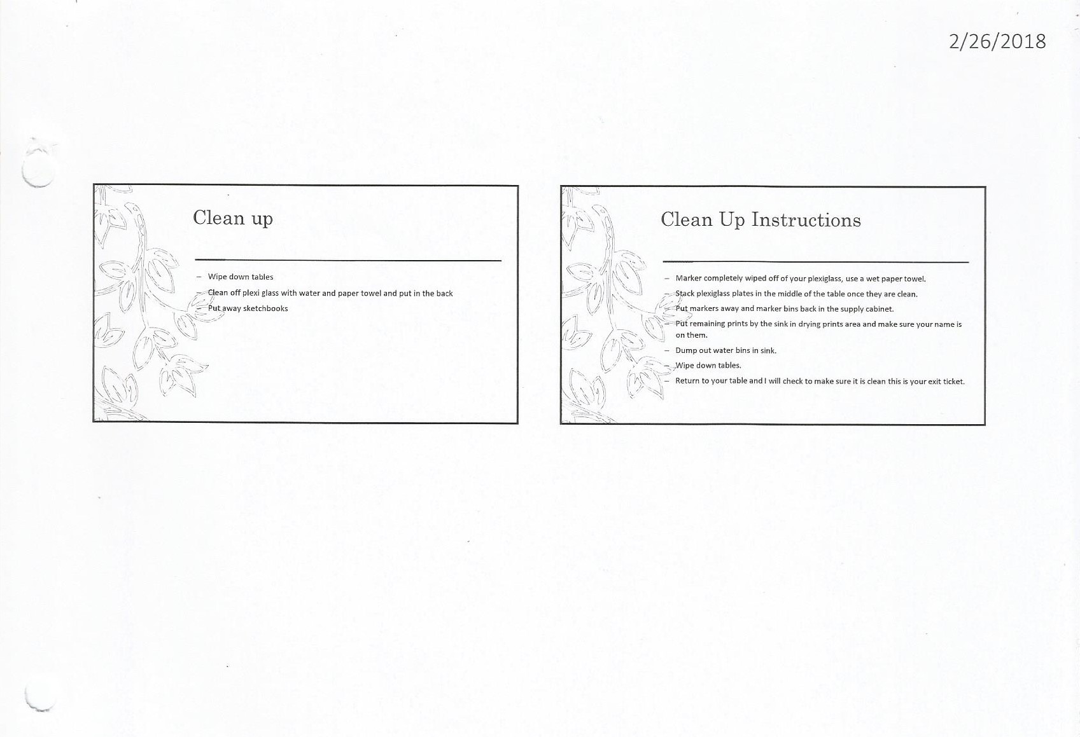

8/9/15 Fahey

