Lesson Plan Title:______Pipe Cleaner Sculpture Project_________ Length:______1 Class____________

Note: Before you plan and write art experiences; pre-assess your students based on the proposed concepts, enduring understandings, and objectives of the unit/lesson(s). You may also gather this information from (previous) teachers, by reviewing already completed art work, consulting curriculum materials, etc., to get a better understanding of what content students already know and what they will need to know to be successful.

Pre-Assessment:
This will need to be done prior to teaching your lesson. Outline the method you will use to determine the skill/knowledge level of your students based on the concepts/enduring understandings/objectives of the lesson. (Hint: turn these into questions.) Be specific in describing what you would recognize as proficient skill/knowledge.
- What is the difference between two-dimensional art and three-dimensional art?
- What materials can we use to make a three-dimensional shape? What can we do to the material to make it stand on its own?
- How can a drawing help us plan to make a sculpture?
- How can we build sculptures using pipe cleaner wire?

Performance:
What will students accomplish as a result of this lesson? This can be presented to students in the form of a story. In this narrative the students take on a role and create a learning product about a specific topic for a certain audience. (RAFT – Role / Audience / Format / Topic)
Tamara’s Class:
Role - Zookeeper
Audience - Zoo Patrons
Format - Sculptures
Topic - Animals

You are zookeepers building a brand new zoo! You need to plan what animals are going to be in the zoo and then make them. You want to make sure that there are a variety, so check with the other zookeepers

Concepts:
List the big ideas students will be introduced to in the lesson. These ideas are universal, timeless and transferrable. Examples of concepts used in art might include: Composition, Patterns, Technique, Rhythm, Paradox, Influence, Style, Force, Culture, Space/Time/Energy, Line, Law/Rules, Value, Expressions, Emotions, Tradition, Symbol, Movement, Shape, Improvisation, and Observation Look for concepts in the standards, content specific curriculum, etc.
Collaboration, Identity, Style

Enduring Understanding (s):
Enduring Understandings show a relationship between two or more concepts; connected with an active verb. The best enduring understandings not only link two or more concepts; but demonstrate why this relationship is important. Like concepts, they are timeless, transferrable and universal.
Artists use symbols and stylistic choices to express their identity.
Artists practice and combine different materials in their sketchbook to take creative risks for their final project.

Standards: (All lessons should address all standards.)
1. Observe and Learn to Comprehend
2. Envision and Critique to Reflect
3. Invent and Discover to Create
4. Relate and Connect to Transfer

Objectives/Outcomes/Learning Targets:
Objectives describe a learning experience with a condition → behavior (measurable) → criterion. Aligned to: Bloom’s – Standards – GLEs - Art learning and, when appropriate, Numeracy, Literacy and Technology. Should be written as: Objective. (Bloom’s: _____ - Standard: _____ - GLE: _____ -Art learning: _____ -Numeracy, Literacy, and/or Technology)
- Given examples of Calders and Jensen’s wire sculpture works of representational animals, students will be able to reflect on how to create three dimensional forms from two dimensional elements such as lines.
  - Art Learning: Artists and Culture AND Art Learning: Ideation
  - Standard: Comprehend
  - Blooms: Analyze
  - GLE: The characteristics and expressive features in art and design allow us to discuss and determine the artist’s intent and purpose.
  - N/L/T: Literacy
- After observing a demonstration on building 3d shapes with pipe cleaners, students will understand and be able to apply lines in three dimensional space to create a skeletal form for their animal sculptures.
  - Art Learning: Tools and Techniques
  - Standard: Create
  - Blooms: Apply
  - GLE: Use symbols to identify and demonstrate characteristics and expressive features of art and design using basic media.
  - N/L/T: Technology
- After working with line in two dimensional and three dimensional artworks, student will be able to discuss how gesture and color scheme express their animal’s personality.
  - Art Learning: Expressive features and characteristics
  - Standard: Transfer
  - Blooms: Analyze
  - GLE: Historical and cultural ideas of the human experience are evident in works of art.
  - N/L/T: Technology
- After creating two and three dimensional versions of their selected animals, students will be able to reflect on how their work and their classmates work was created and understand how their wire wrapping construction techniques lead to a similar end result.
  - Art Learning: Critical Reflection
  - Standard: Reflect
  - Blooms: Understand
  - GLE: Artists, viewers, and patrons make connections among the characteristics, expressive features, and purposes of art and design.
  - N/L/T: Literacy

Differentiation:
Explain specifically how you have addressed the needs of exceptional students at both end of the skill and cognitive scale. Describe the strategies you will use for students who are already proficient and need growth beyond what you have planned for the rest of the class, as well as modifications for students with physical and/or cognitive challenges. Students must still meet the objectives.

Differentiation:  (Multiple means for students to access content and multiple modes for student to express understanding.) | Access (Resources and/or Process) | Expression (Products and/or Performance)
 | simple  provided color scheme  students and picture examples  option to choose animal  simple design/ little detail ( form should resemble and animal and color but does not have to have facial features or completely recognizable, should be expressive) | expressive pipe cleaner animal that follows a color scheme that represents the animal and the student  should stand up on its own  have features of an animal  (legs, hear, ears, tail, body, etc. )
Extensions for depth and complexity: | Access (Resources and/or Process) | Expression (Products and/or Performance)
 | gesture drawing  use of color schemes  looking at form and re-creating it in 3D with pipe cleaners  problem solving on how to make an animal using pipe cleaners | understanding of gesture and expression through body language and color  how to draw gesture,and translate it into 3D form  use 3D form to show gesture and form  learn how to draw/create animal form in 3D and through gestures drawing  using resources and other students to help create forms using pipe cleaners

Literacy:
List terms (vocabulary) specific to the topic that students will be introduced to in the lesson and describe how literacy is integrated into the lesson.
- Line - students will discuss how drawn lines and pipe cleaners are similar.
  - Definition: a mark or stroke long in proportion to its breadth, made with a pen,pencil, tool, etc., on a surface:
- Two Dimensional - Students will have flat, drawn images explained.
  - Definition: having elements of design arranged on a flat surface
- Three Dimensional - Students will have Sculptural work explained.
  - Definition: art that occupies space through the dimensions of height, width, and depth

Materials:
Must be grade level appropriate. List everything you will need for this lesson, including art supplies and tools. (These are the materials students will use.) List all materials in a bulleted format.
- Sketchbooks
- Pencils
- Markers
- Pipe Cleaners
- Example sculptures.
  - Both classes will need their own examples.
- Printed Images of Animals

Resources:

List all visual aids and reference material (books, slides, posters, etc. Be specific; include title, artist, etc. Make reference to where the material can be found. (These are the resources used by the teacher to support/develop the lesson.) List all resources in a bulleted format.
- Visual
  - Teachers should bring images of wire sculptures, such as Calders or Jensen’s, to show the students.
  - Teachers will bring 1-3 example sculptures so students will see what a sculpture COULD look like for this sculpture.
- Reference
  - Teacher will bring in animal books checked out by the library for students to reference, in addition to using the books available in classroom teacher’s room

Preparation:
What do you need to prepare for this experience? List steps of preparation in a bulleted format.
- Instructors would need to create several examples of different animal pipe cleaners.
- Write sheet that lists different types of species of animals.
- Make farm for exhibition after project is completed.
- gesture drawing activity

Safety:

Be specific about the safety procedures that need to be addressed with students. List all safety issue in a bulleted format.
- Pipe Cleaners are sharp on the ends - do not poke other students.
- If you are cutting pipe cleaners with scissors, only cut away from yourself and only cut ONE pipe cleaner at a time.
- Do not hit each other with the pipe cleaners. They may hurt more than you expect.

Action to motivate/Inquiry Questions:
Describe how you will begin the lesson to stimulate student’s interest. How will you pique their curiosity and make them interested and excited about the lesson? What inquiry questions will you pose? Be specific about what you will say and do to motivate students and get them thinking and ready to participate. Be aware of the varying range of learning styles/intelligences of your students. Some ideas might include: telling a story, posing a series of questions, role-playing, etc.
- Students will be told that they will be making a class zoo out of pipe cleaner animals. They will be in charge of coming up with the theme and what sections that the zoo will have. A discussion about what a zoo is will prompt them on what they would like to make. They get to choose if they want to make their zoo with imaginary creatures or real animals.
- Be shown images of Calder and Jensen’s work:
  - Have a discussion with students on what looks more compelling to the viewer when it comes to looking at the animals
    - Can you see what the animal looks like in Calder’s work even though he uses very few lines?
    - Do Jensen’s lifelike animals remind you of real life animals? Do they look like they can move on their own?
    - How do you think each piece was made?
    - Which type of sculptural style do you like looking at? One that has simple lines or one that has more lifelike form? Both are okay to make for your final sculpture.
  - We get their attention first by mentioning that this is our last project for the semester with them, which would be a pipe cleaner animal zoo. Showing them Ruth Jensen’s
- “All of you, at some point this semester, have drawn animals. Most animals are pretty similar, so you have drawn them the same way - a body, a head, four legs, maybe a tail. But we can see that though they are similar, there are a lot of differences between them. Can anyone point out any differences?”
- Prompt students to denote several differences in the pictured animals - for example, hippos have a large, round body while giraffes are thin and triangular.
- “In order to make animals that look different, you need to figure out what is different about them. I want you to select an animal picture, draw on it in order to figure out what shape its body is, and then try and make those drawn shapes out of pipe cleaners.”
- Show an example of a lined animal and an example sculpture.
- Ask several guiding questions to get them to understand the parts they need to identify and make.
  - All animals have…
    - …legs.
    - … a head.
    - … a body.
    - … maybe a tail.
- Reasoning - This process will show them what I want but also allow them to choose animals they are more interested in. It will also allow them to reason out their construction with drawing and sculpture at the same time.

Ideation/Inquiry:
Ideation is the creative process of generating, developing, and communicating new ideas, where an idea is understood as a basic element of thought that can be visual, concrete or abstract. List and describe inquiry questions and processes you will engage students in to help them develop ideas and plans for their artwork.
Tamara’s Class
- Questions to help Ideation
  - Is that animal's head/legs/body/tail/other part…
    - Long? Short? Round? Boxy?
  - How can you use a pipe cleaner/line to show that part?
    - Make a circle? Make a zig-zag?
  - Does the color of the pipe cleaner matter to you?
    - Abstract colors vs. specific colors.
- Questions to help construction
  - How do you get it to stand up?
    - Make a base? Make stronger legs? Make it sit down?
  - How do you connect pipe cleaners?
    - Tie the ends? Wrap them around each other? Make hooks?
- Questions to help Student Self Reflection
  - How do I know if it is good?
    - Stand back ten feet. Can you see it differently now?
    - What parts do you think are good? Why? What parts do you think are not good?

Brittany’s class, we will ask the students the same questions. To connect student learning with the themes of our previous assignments, we will ask students about how they can choose warm and cool color schemes with their pipe cleaners to represent their animal’s characteristics. Students will also reflect on what personality traits they have in common with the animal of their choice, so they can make connections to how the animals they chose represent their identity.

Considerations about color for ideation:
- Warm colors are happy, energizing, active, adventurous, angry, attention-getting, and courageous
  - Red: angry and adventurous
  - Pink: warm, loving, happy, nice
  - Orange: cheerful, social, and curious
  - Yellow: cheerful and sunny, sometimes poisonous
- Cool colors are calm, peaceful, sad, imaginative, and mysterious
  - Green: growth, greedy, and compassionate
  - Blue: sad, peaceful and curious
  - Purple: imagination, creativity, and mysterious

Instruction:
Give a detailed account (in bulleted form) of what you will teach. Be sure to include approximate time for each activity and instructional methodology: skills, lecture, inquiry, etc. Include motivation and ideation/inquiry where appropriate; including what student will understand as a result of the art experience

Day 1 | Instruction - The teacher will... (Be specific about what concepts, information, understandings, etc. will be taught.) Identify instructional methodology. KNOW (Content) and DO (Skill)  Brittany’s Class  Circle up (5 minutes):  - Home teacher does some sort of introductory warm-up activity that gages how students are feeling and sets the learning tone for the rest of the day  Introduction  - “For our last project, we will learn how to make wire sculptures out of pipe cleaners. Specifically, we will be making a pipe cleaner animal zoo.”  - What is the purpose of a zoo?  - How many different kinds of animals live at the zoo?  - What do the living environments of animal zoos looks like?  - Show a list of different animals at the zoo:  - mammals: bears, tigers, lions, dogs, cats, pigs, mice, horses, monkey  - birds: penguins, ostrich, parrot, dove, hummingbird, eagle  - reptiles and amphibians: frogs, alligators, komodo dragons, lizard, snake  - sea creatures: seals, whales, fish, dolphins, platypus, octopus  - insects: butterflies, moths, beetles, ants, praying mantis, catapillars  - “Here are some examples of some professional artists that use wire to make sculptures.”  - Show images of Ruth Jensen and Alexander Calder’s work:  Alexander Calder:  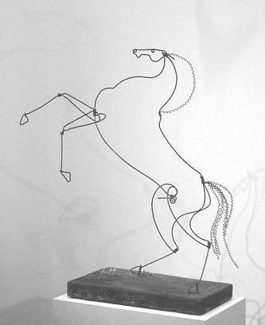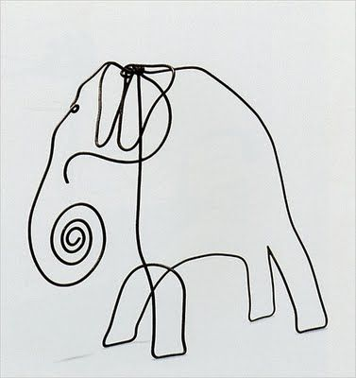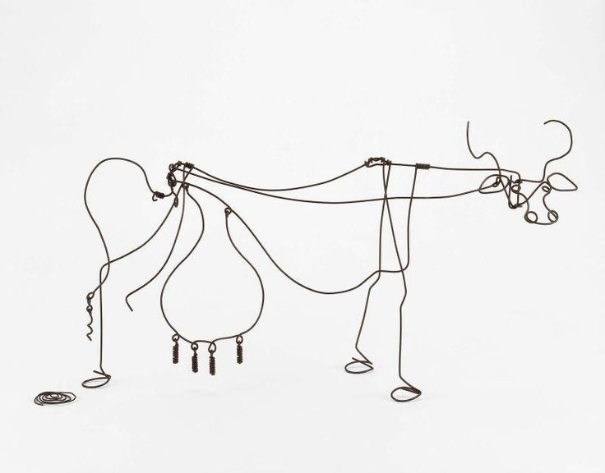  Ruth Jensen:  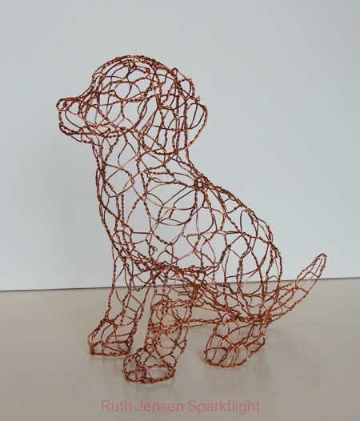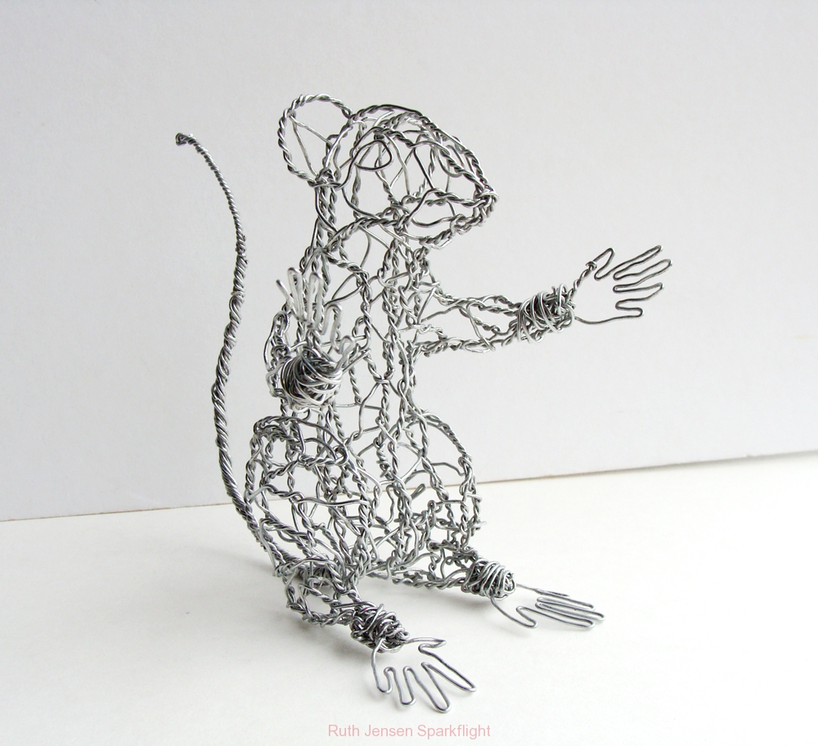  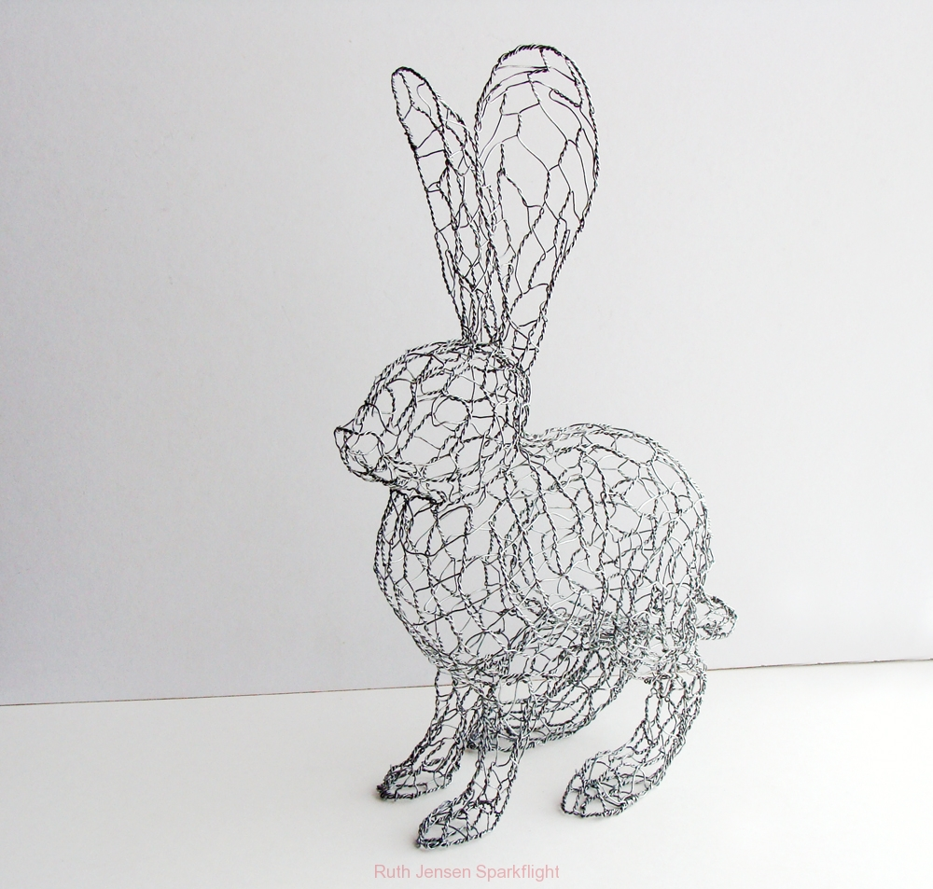  - Discuss the images:  - How do you think this was made?  - How do the lines create shapes?  - How do the lines connect?  - How does the line/lack of line fill out the sculpture?  - What is the difference between a two-dimensional animal and a three-dimensional animal?  - show students the definitions of line,two-dimensional art, and three-dimensional art (see literacy box in lesson plan)  - Other questions to consider:  - Can you see what the animal looks like in Calder’s work even though he uses very few lines?  - Do Jensen’s lifelike animals remind you of real life animals? Do they look like they can move on their own?  - How do you think each piece was made?  - Which type of sculptural style do you like looking at? One that has simple lines or one that has more lifelike form? Both are okay to make for your final sculpture.  - “Most of these artists started with a beginning sketch of the animal to plan out their design for their sculpture. And this did not take that long to make. Some artists like to use gesture drawings, which are simple line drawings that look like stick figures. We would like you to make a couple gesture drawings of some animals so that you know how to make a 3-D sculpture from a 2-D drawing.  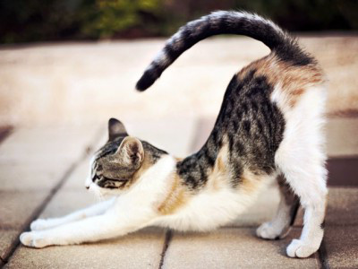  This is the image that students will be drawing from (displayed on the SMARTBoard). The teacher will make a gesture drawing of the cat, spending about 30 seconds to a minute making a stick figure version for the student. Then, the teacher will lay the drawing on the table and make a skeleton outline of the cat by laying pipe cleaners on top of the drawing and mirroring the gesture. The students are welcome to make suggestions on how the teacher can make the rounded forms of the cat, such as the head, torso, and pelvis. Afterwards, the students will do two one minute gesture drawings of the cat. The teachers will go around and check their work, encouraging them to make a stick figure skeleton of the cat.  - “This is something that you can try with your animal sculpture when you use a photo as inspiration. What we want you to understand is that artists use drawings to figure out the form and movement of an animal before they start building their sculptures.”  - “Today, we will be making animals out of pipe cleaners for Miss Brittany’s class zoo as part of our Polaris exhibition.” Show examples of animal pipe cleaners that the instructors made, preferably one of each kind of animal. “When you make your sculptures, I want you to think about what your favorite animal is and what you and that animal have in common. If you choose a giraffe, is it because you’re tall? If you choose a mouse, is it because you’re shy? I also want you to think about how to keep the form of the animal simple. Notice how in Calder’s work, we see that there’s an animal but he doesn’t use a ton of wire to do so. We also want to make sure that there aren’t a ton of the same kind of animals. When we go to a zoo, we make sure that there’s lots of diversity so viewers get to see many different things.”  - Construction notes: “It’s important to think about building the spine or skeleton of the animal before you think about details. Think about building it like drawing a stick figure. You want to make sure that your lines are simple and capture the gesture before adding more details and more pipe cleaners. Start with the head, spine, and legs. Make sure the animal can stand on its own. Then, build the rib cage and the hips using circles and ovals. Bend the pipe cleaner to make a circle and wrap the ends around the spine of the animal to make sure it’s attached. Do this a couple of times. You also may want to consider wrapping pipe cleaners around the legs to make sure they are stable enough to hold the weight of the animal.”  - Briefly talk about safety protocols of how to cut pipe cleaners safely  - Pipe Cleaners are sharp on the ends - do not poke other students.  - If you are cutting pipe cleaners with scissors, only cut away from yourself and only cut ONE pipe cleaner at a time. DO NOT run around the classroom while holding scissors.  - Do not hit each other with the pipe cleaners. They may hurt more than you expect.  - “Also, I want you to think about how you will use color in your sculptures. The colors of pipe cleaners that you use to make your animal do not have to look realistic, but I want you to think about using warm or cool colors. Think about the way your animal behaves and interact with people. Is it friendly or dangerous? Is it curious or shy? You’ll want to pick your colors based on that.”  - Show the list of warm and cool color traits.  - Warm colors are happy, energizing, active, adventurous, angry, attention-getting, and courageous  - Cool colors are calm, peaceful, sad, imaginative, and mysterious  - Display a list of mammals, sea creatures, insects, amphibians, reptiles, and birds on the SMARTBoard for students to reference. Also, bring in images from the Polaris’s resource room  - “If you are done constructing your animal and get it approved by the teacher, you can help build the structures for our zoo. I want you to find other classmates that have animals similar to yours and talk to them about what kind of background you want your animal to interact with. You can use white or colored paper to make the background--and don’t forget to use color (markers, colored pencils, or oil pastels--no watercolor). You also might want to consider making pipe cleaner trees and plants for your animals to interact with.”  - “Since today is our last day making art, I want you to focus on making an animal with a simple structure that can stand on its own. Think about making the skeleton of the animal before creating its skin, fur, and feathers. We will come around and help you with that. When you are finished making your animal’s skeleton, you can start thinking about adding details to your animal. Keep in mind that we only have one day for this project, so make sure that you are focused and work hard.”  Work time  - The teacher will walk around the classroom and assist students with constructing the skeleton of their animal.  - When students are finished constructing their skeleton, they can add decorations.  - When students are completely finished with their animal, they can free draw in their sketchbook.  Clean-up  - Students will sweep up pipe cleaners and put them away in the giant ziploc baggie. They will also throw away scraps that are too small to use for future projects (any scrap that is too twisted or shorter than an adult pinky finger).  - Put away scissors in their drawers.  - Put away free drawing materials, close sketchbook on desk, and sit in seats quietly and wait for instructions.  Closing thoughts  - The teachers will thank the students for working hard and creating beautiful art. They will also give every student a print of the sea turtle example that Emily created for the first lesson to keep in their sketchbook as an extra souvenir  - Students will quietly line up at the door for recess..  Tamaras Class  - Start of the Day (8:15-8:30)  - Students will enter and carry out their morning tasks. (Storing backpacks, preparing snacks, taking attendance, etc.)  - When this process is complete, the classroom teacher will turn control over to the art teacher.  - Introduction (8:30-8:35)  - This section achieves Objective 1  - Last week we tried to make some animal sculptures with pipe cleaners. This week, we are going to learn how to do it.  - Show images of Calder and Jensen’s artworks. Discuss the images:  - How do the lines create shapes?  - How do the lines connect?  - How does the line/lack of line fill out the sculpture?  - Ideation (Ends at 8:40 at latest.)  - Students will be shown printed images of various animals in various poses.  - “All of you, at some point this semester, have drawn animals. Most animals are pretty similar, so you have drawn them the same way - a body, a head, four legs, maybe a tail. But we can see that though they are similar, there are a lot of differences between them. Can anyone point out any differences?”  - Prompt students to denote several differences in the pictured animals - for example, hippos have a large, round body while giraffes are thin and triangular.  - “In order to make animals that look different, you need to figure out what is different about them. I want you to select an animal picture, draw on it in order to figure out what shape its body is, and then try and make those drawn shapes out of pipe cleaners.”  - Show an example of a lined animal and an example sculpture.  - Ask several guiding questions to get them to understand the parts they need to identify and make.  - All animals have…  - …legs.  - … a head.  - … a body.  - … maybe a tail.  - Get started by drawing your animal on the image or in your sketchbook. When you are done, come to me for pipe cleaners!  - Work Time (8:40 - 9:00)  - This section starts Objective 2.  - Students will work while the teacher hands out supplies and assists with ideation.  - Midpoint Discussion (9:00 - 9:05)  - This section starts Objective 3.  - Gather students attention.  - Show images of architecture, Da Vinci's drawings/sculptures, and some of Calder's larger sculptures.  - Explain that these started as drawings but were made into sculpture. Discuss how artists work with two-dimensional art to help plan three-dimensional art.  - Ask students what parts of their two-dimensional art have helped their three-dimensional art.  - Work Time (9:05 - 9:15)  - This section continues Objective 2.  - The teacher will patrol and talk to every student in case they did not talk during the Midpoint Discussion, asking similar questions.  - Discussion (9:15 - 9:25)  - This section achieves Objective 4 and concludes Objective 2 and 3.  - Gather students attention and have them place all of their sculptures on the Gladiator Circle carpet.  - Students will carry out a “gallery walk” style discussion. The questions the teacher will prompt with are:  - How did the line drawings you have done help you with this sculpture?  - Now that you have made your sculptures, do you think you know how Calder and Jensen made theirs? Do you think you could make theirs?  - Do you see parts of the animals your classmates made that seem well made? How do you think they did it? | Learning - Students will... i.e.: explore ideation by making connections,  comparing, contrasting; synthesize possibilities for each painting technique; etc. (Be specific about what will be the intended result of the instruction as it relates to learning.) UNDERSTAND  Learning: Comparing analogous situations--transferring insights into new contexts  Learning: refining generalizations and avoiding oversimplification; explore thoughts underlying feelings and feelings underlying thoughts  Learning: exercising fairmindedness  Learning: thinking independently; developing intellectual perseverance  Learning: exercising fairmindedness | Time  5 minutes (8:30-8:35)  5 minutes  (8:35-8:40)  5 minutes (2 minutes for instruction and 3 minutes for work time) (8:40-8:45)  5 minutes (8:45-8:50)  30 minutes  (8:50-9:20)  5 minutes  (9:20-9:25)  5 minutes (9:25-9:30)

Student reflective/inquiry activity:
Sample questions and activities (i.e. games, gallery walk, artist statement, interview) intended to promote deeper thinking, reflection and refined understandings precisely related to the grade level expectations. How will students reflect on their learning? A participatory activity that includes students in finding meaning, inquiring about materials and techniques and reflecting about their experience as it relates to objectives, standards and grade level expectations of the lesson.)
At the end of class, the students will go through a “gallery walk” style discussion. Their animals will be grouped together into a “zoo” and they will be asked to look at their and their classmates works together. They will be asked to discuss the following:
- How did the line drawings you have done help you with this sculpture?
- Now that you have made your sculptures, do you think you know how Calder and Jensen made theirs? Do you think you could make theirs?
- Do you see parts of the animals your classmates made that seem well made? How do you think they did it?

Post-Assessment (teacher-centered/objectives as questions):  Have students achieved the objectives and grade level expectations specified in your lesson plan? | Post-Assessment Instrument:  How well have students achieved the objectives and grade level expectations specified in your lesson plan? Include your rubric, checklist, rating scale, etc.
- Has the student been able to analyze and create a three dimensional form from two dimensional elements?  - Has the student been able to use the materials to create an effective three dimensional shape?  - Has the student been able to discuss how creating two dimensional plans for three dimensional creations has been useful throughout history?  - Has the student been able to discuss how their exploration of this creative process allows them to understand how other artworks have been created? | 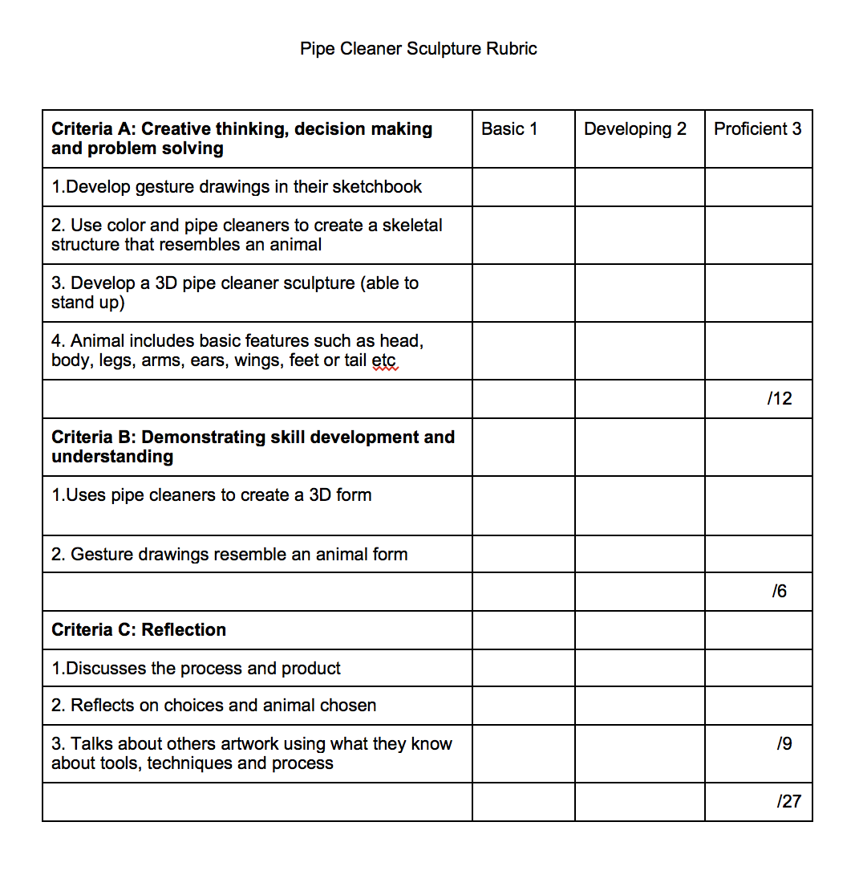

Self-Reflection:
After the lesson is concluded write a brief reflection of what went well, what surprised you, and what you would do differently. Specifically address: (1) To what extent were lesson objectives achieved? (Utilize assessment data to justify your level of achievement.) (2) What changes, omissions, or additions to the lesson would you make if you were to teach again? (3)What do you envision for the next lesson? (Continued practice, reteach content, etc.)

Appendix: Include all handouts, prompts, written materials, rubrics, etc. that will be given to students.

8/9/15 Fahey

